HOTEL AVA
USER MANUAL
Smart Hotel Reservation and Recommendation System

A Usage Guide for Guests and Administrators
Hotel Ava Malate, Manila | October 2026

Contents
• 1. Introduction
• 2. System Flow
• 3. How to Access the System
• 4. Guest (User) Manual
• 4.1 Home Page | 4.2 Rooms & Suites | 4.3 Room Details | 4.4 Creating an Account
• 4.5 Email Verification | 4.6 Sign In | 4.7 New-Device Verification | 4.8 Quick Sign-In (QR)
• 4.9 Forgot & Reset Password | 4.10 Making a Booking | 4.11 My Bookings | 4.12 My Reviews
• 4.13 Profile | 4.14 Changing Your Avatar | 4.15 Account Menu | 4.16 Settings
• 4.17 Ask Ava (AI Chat) | 4.18 Help Center
• 5. Admin Manual
• 5.1 Admin Portal | 5.2 Dashboard | 5.3 Bookings | 5.4 Rooms | 5.5 Guests
• 5.6 Calendar | 5.7 Reviews | 5.8 AI Assistant | 5.9 Settings
• 6. FAQ / Troubleshooting
• 7. Demo Accounts

1. Introduction
Hotel Ava is a Smart Hotel Reservation and Recommendation System for Hotel Ava Malate — a drive-in hotel located at Madre Ignacia St. cor. Quirino Ave., Malate, Manila. The system makes it easy to search for rooms, book online, pay, and manage the hotel using AI-powered features.
There are two types of users of the system:
• Guest — customers who search for rooms, book online, and leave reviews.
• Admin — hotel staff/management who handle bookings, rooms, guests, calendar, reviews, and analytics through a separate Admin Portal.
Key features:
• Room search and recommendation — filters (room type, price, rating, promos) and AI recommendations.
• AI Boost pricing — discounts derived from AI demand forecasting, shown in the price breakdown.
• Online booking and payment — via PayMongo (cards, e-wallets; in test mode for the demo).
• Reviews and ratings — written by guests and visible per room by admins.
• Admin analytics — demand and revenue forecasts, discount ideas, and hotel statistics.
• Account security — one-time codes (OTP) on new devices, Google sign-in, QR Quick Sign-In, device management, password changes, and scheduled account deletion.
• Ask Ava AI assistant — a floating chat assistant on every page plus a full Help Center.

2. System Flow
Guest flow (complete customer journey):
1. Home Page → fill in the search bar (Stay Dates, Guests, Budget) → CHECK AVAILABILITY
2. Rooms & Suites → apply filters and click the room you want
3. Room Details → review the price, AI Boost discount, and amenities → click Reserve
4. Sign In / Register (if not logged in yet) → verify your email with the one-time code → on a new device, verify it's you with the OTP
5. Booking page → confirm the dates, guests, and total → Proceed to Payment
6. PayMongo checkout → when successful, the Booking Confirmation page appears
7. My Bookings → track the status; after the stay → My Reviews to leave a rating
Admin flow (for hotel staff):
1. Visit the Admin Portal (/admin) → Sign In with an admin account
2. Dashboard → Operations (arrivals, downpayment, in-house), Needs Attention (refunds), Performance (revenue, occupancy, AI insights)
3. Switch to Bookings / Rooms / Guests / Calendar / Reviews using the sidebar
4. AI Assistant → Smart Forecast, Discounts, and Hotel Stats for data-driven decisions

3. How to Access the System
• Browser — use an up-to-date Chrome, Brave, Edge, or Firefox.
• URL — in development: `http://localhost:5173` (frontend), connected to the backend at `http://localhost:5000`.
• Internet connection — the database (Supabase) and payment gateway (PayMongo) are cloud-hosted, so an internet connection is required.
• Device — runs on desktop and mobile browsers (fully responsive pages).

4. Guest (User) Manual

4.1 Home Page
This is the first page you see when opening the system. The header shows the logo and Hotel Ava on the left, Home, Rooms & Suites, About, and Contact Us in the middle, and the Sign In button on the right (plus the account menu once you are logged in). Below the "Dare To Be Different here" hero banner is the search bar, followed by the Featured Rooms section. The floating Ask Ava assistant button sits at the bottom-right corner (see 4.17).
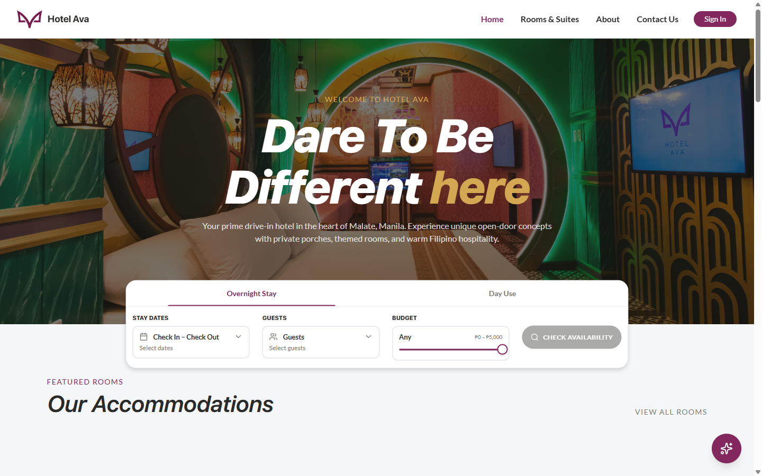
Figure 1. Home Page — hero, search bar, and featured rooms
How to search for a room from the Home Page:
1. Select the stay type: Overnight Stay or Day Use (the tabs above the search bar)
2. Click Stay Dates and choose the check-in and check-out dates
3. Under Guests, select the number of adults (and children, if applicable)
4. Adjust the Budget slider (₱0 – ₱5,000) or set it to "Any" for no limit
5. Click the CHECK AVAILABILITY button — you will be taken to the Rooms & Suites page, pre-filtered with your selections

4.2 Rooms & Suites
This page lists all 13 rooms of Hotel Ava. The Filters panel on the left lets you narrow down by Room type (Deluxe, Executive Deluxe, Junior Suite, Standard, Superior Suite), Price per night slider, Guest rating (Any, 4.0 & up, 4.5 & up), and Promotions (rooms with an active promo). Each room card shows the photo, guest rating, capacity, room name, amenities (Air Conditioning, Free WiFi, Cable TV, Parking, Hot & Cold Shower), the nightly rate, and the day use rates (3h, 6h, 8h, 12h).
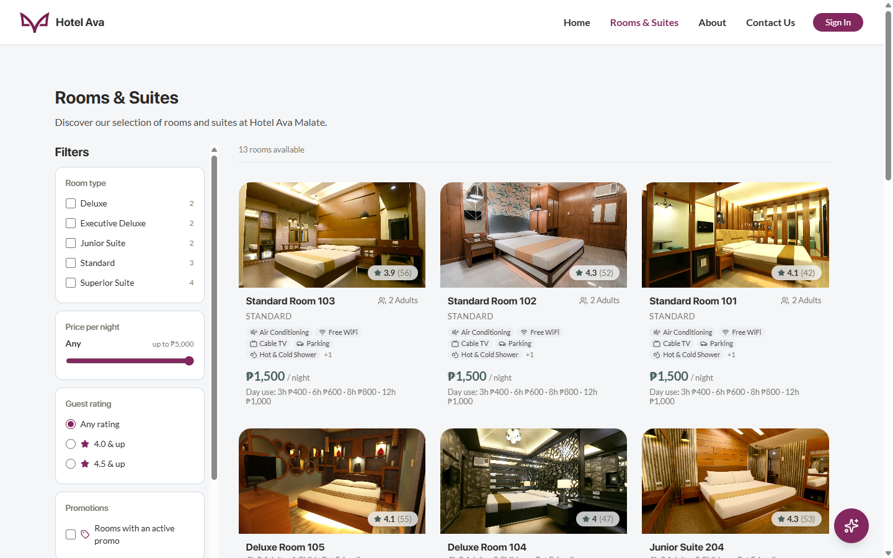
Figure 2. Rooms & Suites — filters and room cards
Steps:
1. Use the checkboxes and sliders in the Filters panel to narrow by type, price, and rating
2. Check the result count at the top ("13 rooms available")
3. Click a room card to open its details
4. If a room has a promo, its badge is shown on the card

4.3 Room Details and Pricing
The Room Details page shows the full information of the selected room: the stay type selector (Overnight Stay / Day Use), check-in date, time slots, and number of guests. On the right is the Price breakdown: room rate, the AI Boost discount (e.g., 15% off — a discount derived from the system's AI demand forecasting), taxes and fees, and the Total. An "About this room" section covers the description, amenities, and the room policies.
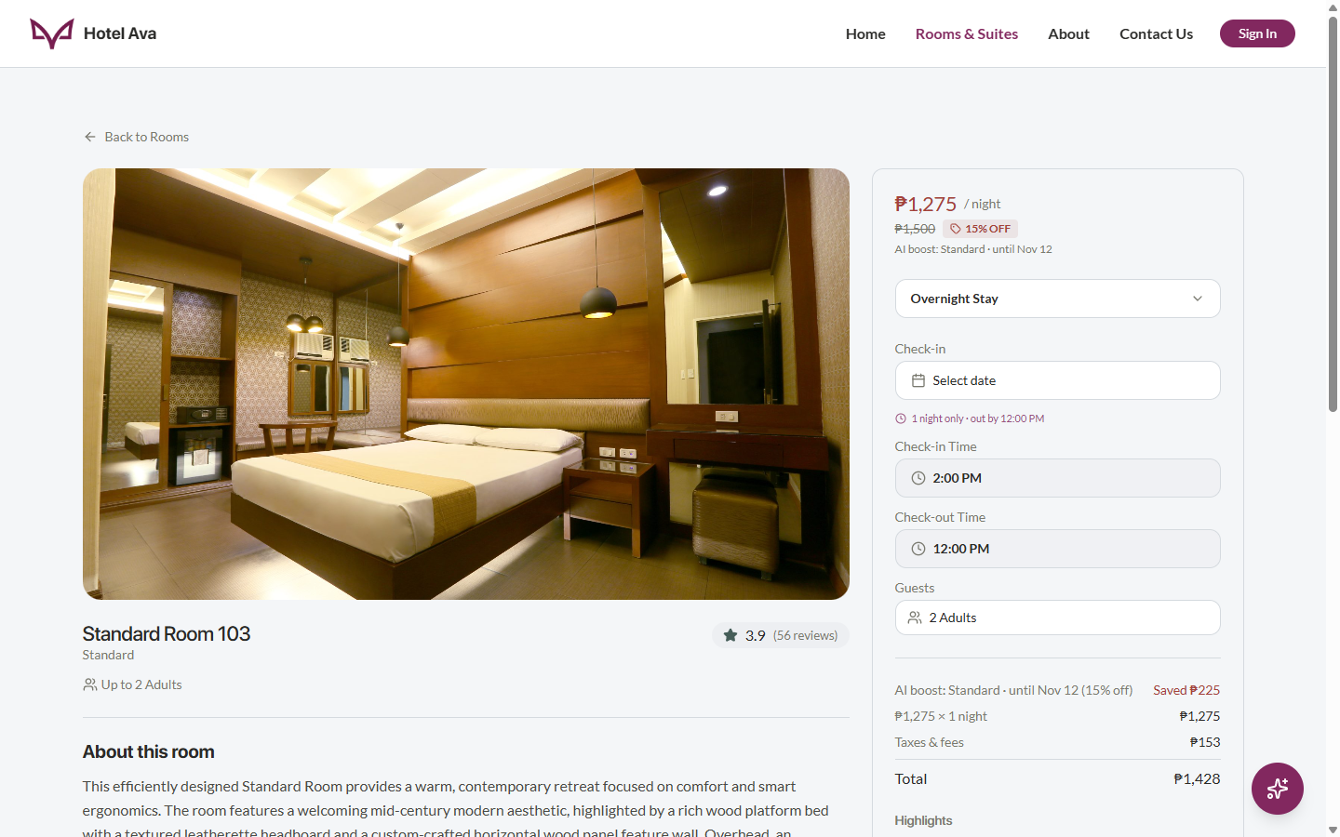
Figure 3. Room Details — stay setup and price breakdown
Steps:
1. Select Overnight Stay or Day Use at the top of the form
2. Set the date, time, and number of guests
3. Review the Price breakdown — the discount, taxes, and total are calculated automatically
4. Click the Reserve / Book button — if you are not logged in yet, you will be taken to the Sign In page first

4.4 Creating an Account (Register)
The Register page offers two options: the quick Continue with Google button, or manually filling out the form (First Name, Last Name, Email, and a Password with a minimum of 8 characters). The Terms of Privacy checkbox must be ticked before the Create Account button becomes active.
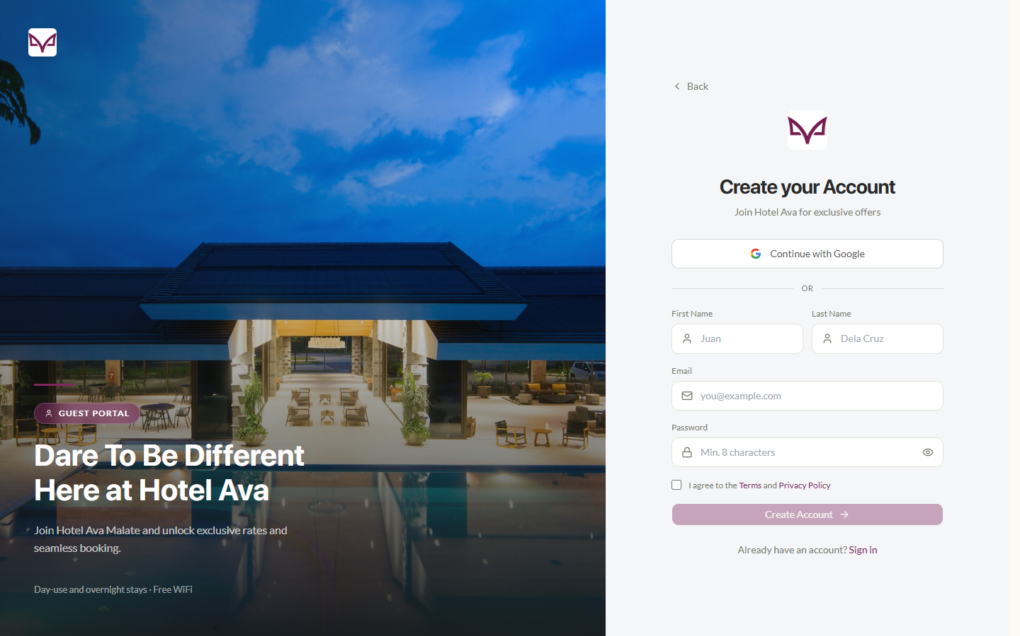
Figure 4. Register page — creating a new account
Steps:
1. On the Sign In page, click the Create one / Sign Up link
2. Choose Continue with Google or fill out the form manually
3. Create a password with 8 or more characters
4. Tick "I agree to the Terms and Privacy Policy"
5. Click Create Account — then verify your email (see 4.5)

4.5 Email Verification
After registering, the system sends a one-time code to your email address to prove that it is really yours. Open the Verify Email page and enter the 8-digit code. If you prefer copying, the Paste the Code page accepts the whole code in a single field. Once verified, you can sign in.
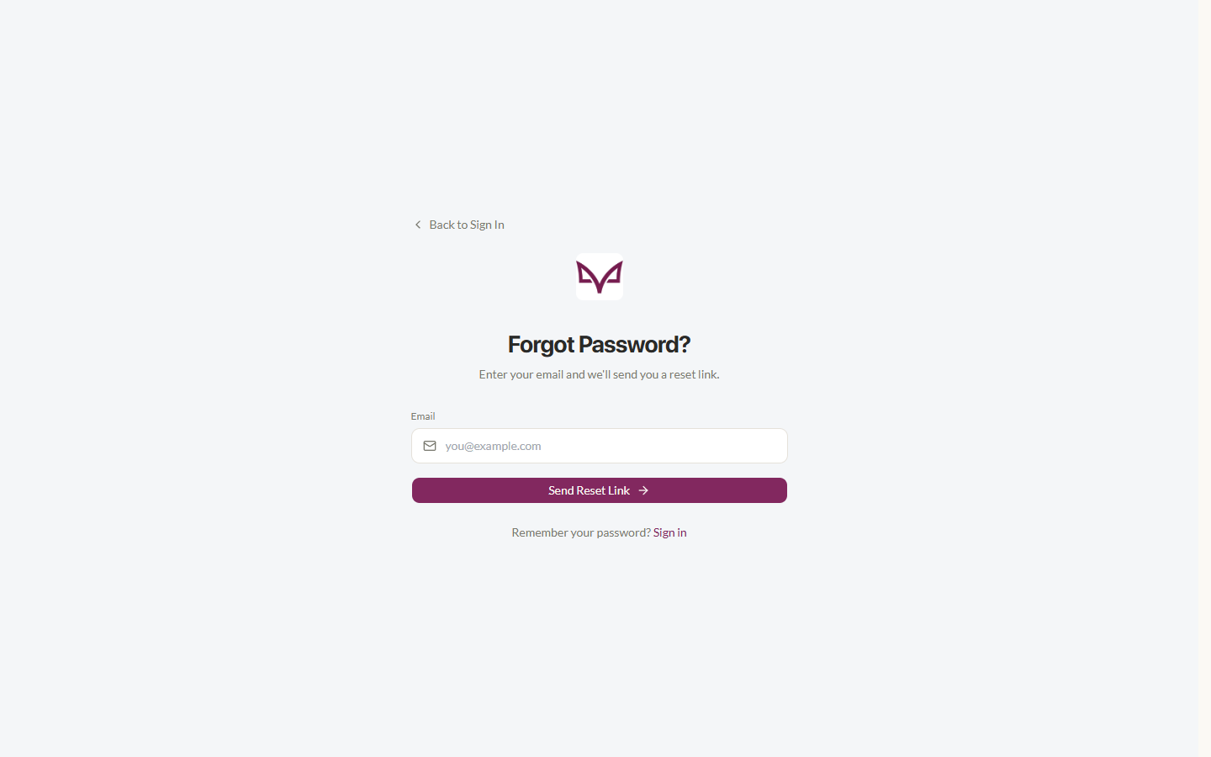
Figure 5. Verify Email — enter the one-time code sent to your email
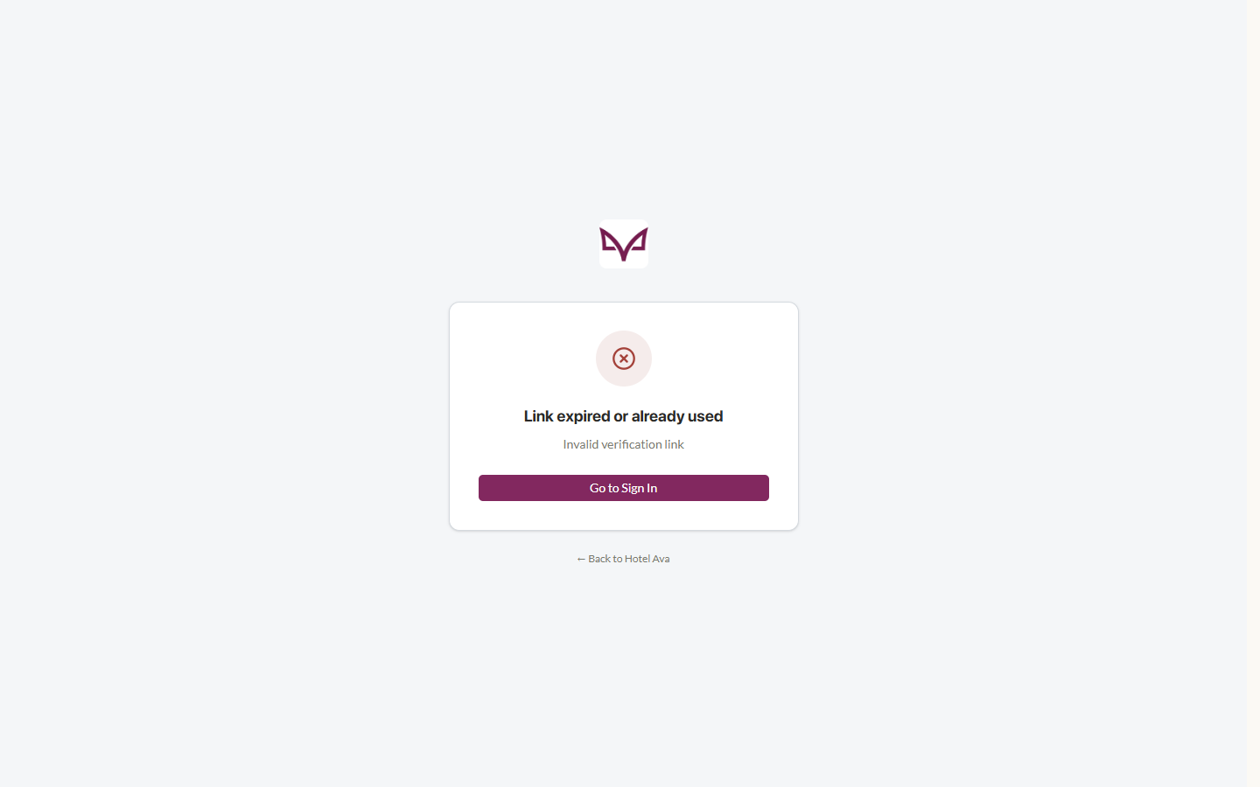
Figure 6. Paste the Code page — an easier way to enter the code from your email
Steps:
1. Open your inbox and find the verification email from Hotel Ava
2. On the Verify Email page, type the 8-digit code
3. Or click the Copy Code page and paste the code in one field
4. Submit — after verification you are redirected so you can sign in
5. No email yet? Check the Spam/Junk folder, or request a new code

4.6 Sign In
There are three ways to sign in: (1) Continue with Google, (2) Quick Sign-In with a QR code from another device (see 4.8), and (3) Email + Password. The "Forgot password?" link below the form resets your password (see 4.9).
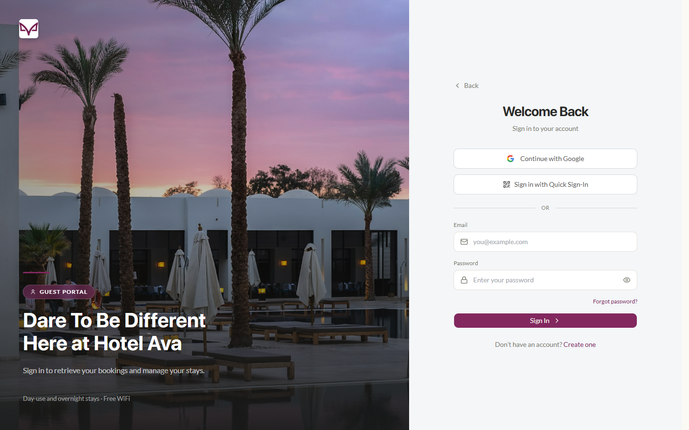
Figure 7. Sign In page — Google, Quick Sign-In, and password
Steps:
1. Go to the Sign In page (or click the Sign In button in the header)
2. Enter your email and password — or click Continue with Google
3. Click the Sign In button
4. If it is your first time on that device, complete the verification in 4.7 first

4.7 Sign-In Verification on a New Device
For your account's protection, signing in from a new device or browser triggers the "Verify it's you" dialog. The system emails you an 8-digit one-time code (OTP) — enter it and click Verify and continue. A countdown shows when you can click Resend code. After the device is verified, it is remembered — your next sign-ins from the same device will not ask for the code again.
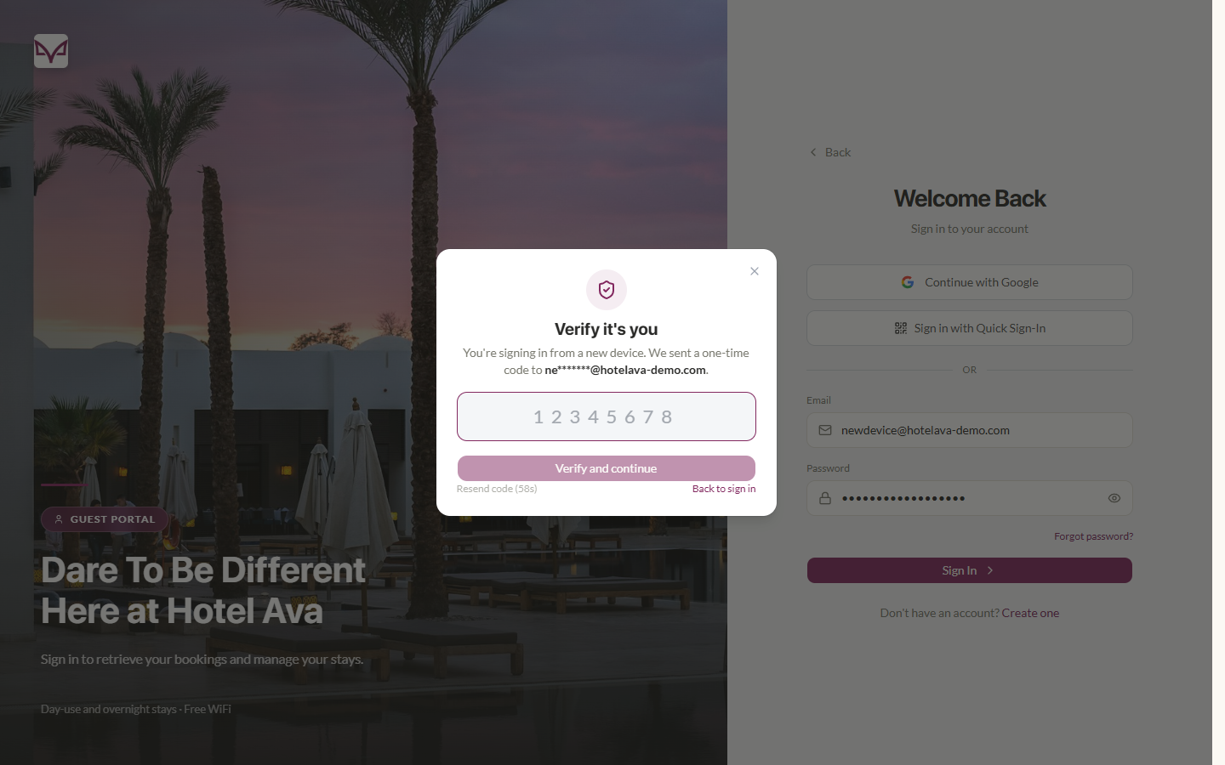
Figure 8. Verify it's you — one-time code requested on a new device
Steps:
1. Sign in with your email and password as usual
2. When the Verify it's you dialog appears, open your inbox
3. Enter the 8-digit code and click Verify and continue
4. Nothing arrived? Click Resend code after the countdown, or check Spam/Junk
5. You can also click Back to sign in to cancel and try again later

4.8 Quick Sign-In with QR
Quick Sign-In lets you sign in to a new device without typing a password — you approve it from a device where you are already logged in. The request expires after about 5 minutes.
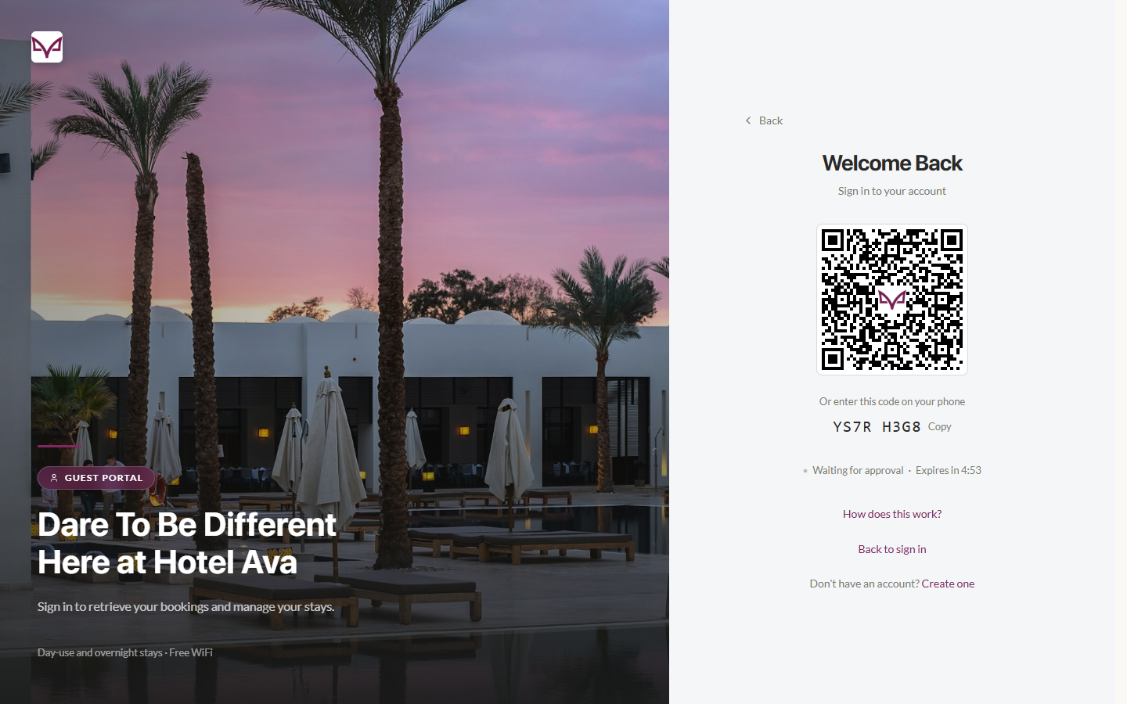
Figure 9. Quick Sign-In — QR code and device code shown on the new device's login page
On the new device (the one signing in):
1. Open the Sign In page and click Sign in with Quick Sign-In
2. A QR code and a device code (e.g., YS7R H3G8) appear, with the status "Waiting for approval" and the expiry countdown
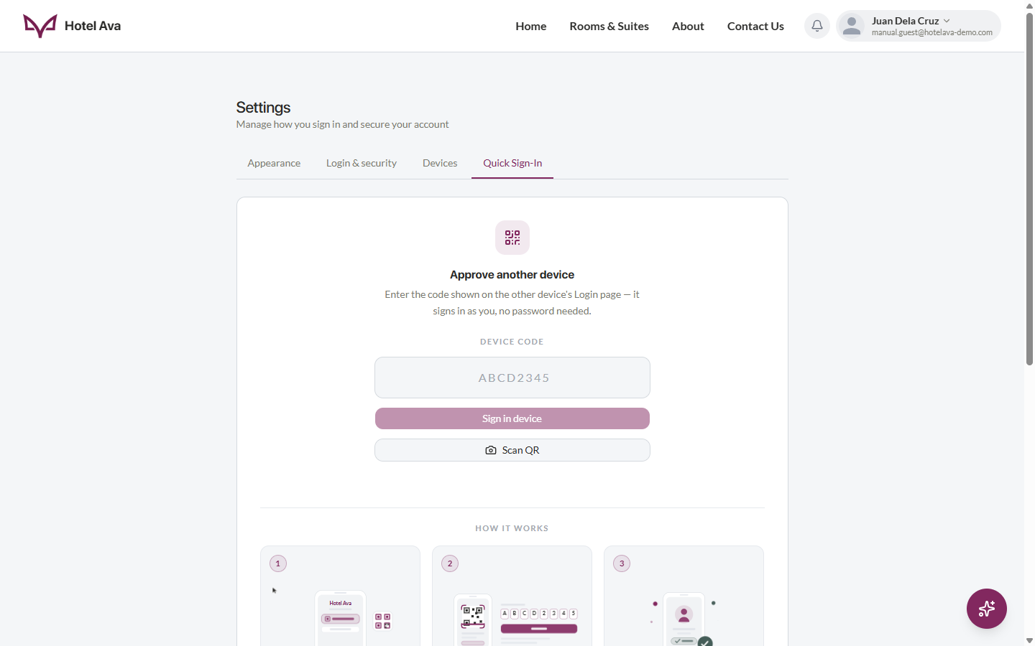
Figure 10. Settings › Quick Sign-In — approve the other device from your signed-in account
On your already signed-in device (approving):
1. Go to Settings › Quick Sign-In
2. Type the device code shown on the other device and click Sign in device — or click Scan QR and point the camera at the QR code
3. The new device is signed in instantly — no password or OTP needed

4.9 Forgot and Reset Password
If you no longer remember your password, the system can send a password reset link to your email.
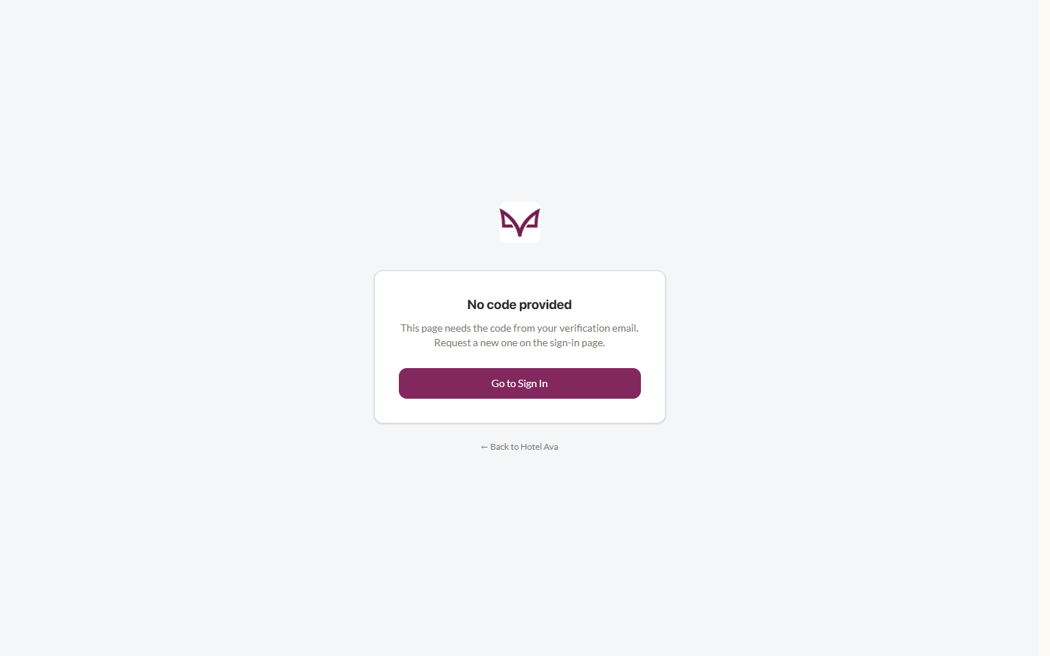
Figure 11. Forgot Password — enter your email to receive a reset link
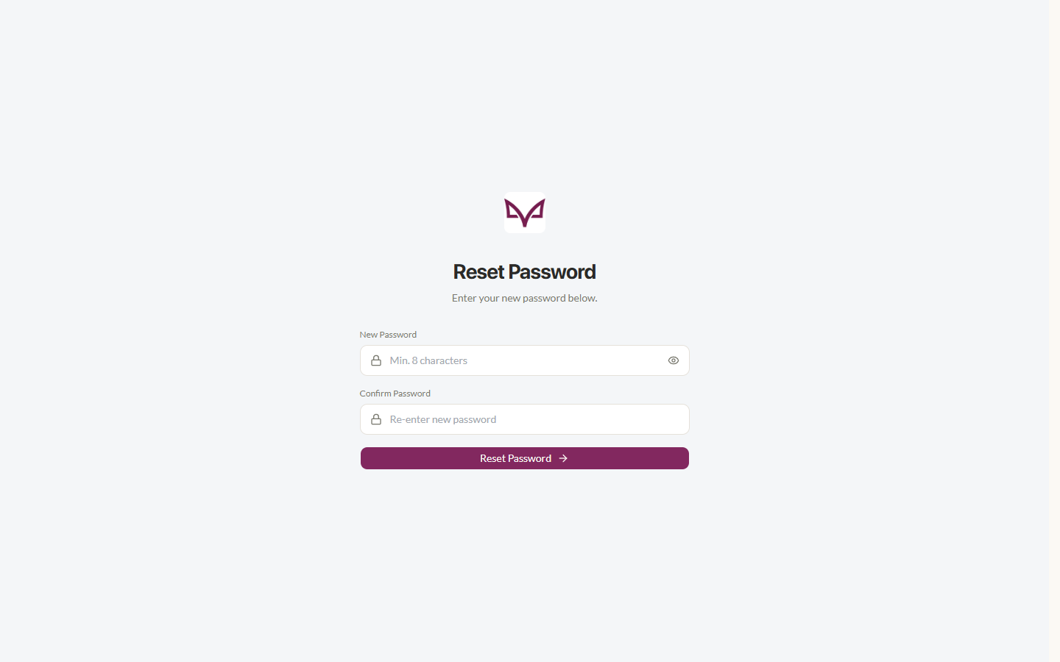
Figure 12. Reset Password — set and confirm your new password
Steps:
1. On the Sign In page, click Forgot password?
2. Enter your email address and click Send reset link
3. Open the reset email from Hotel Ava and click the link (check Spam/Junk if needed)
4. On the Reset Password page, type a new password twice (new + confirm)
5. Save — then sign in with your new password

4.10 Making a Booking
From Room Details, fill out the booking form: confirm the stay dates and times, number of guests, and any special requests. The full price breakdown is shown before payment. Payment is made via PayMongo (cards, e-wallets, and more — in test mode for the demo system).
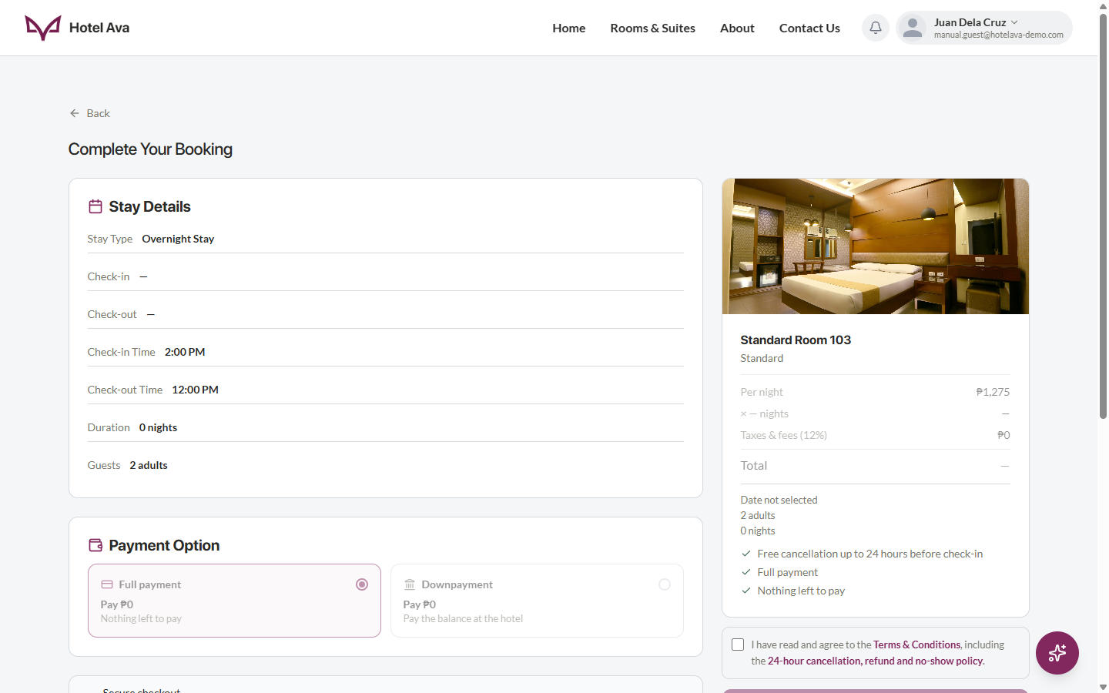
Figure 13. Booking page — stay confirmation and payment
Steps:
1. From Room Details, click Reserve / Book Now
2. Confirm the dates, times, guests, and total amount due
3. Click the Proceed to Payment / Pay button
4. Complete the PayMongo checkout (for the demo: use the test card provided by PayMongo)
5. When the payment succeeds, the Booking Confirmation page appears with your booking reference
6. If the payment fails, a Payment Failed page appears with an option to try again
7. You will receive a confirmation email, and the booking will appear under My Bookings
After a successful payment, the system emails you a Booking confirmation email with your booking reference, stay details, amount paid, and balance due. The same Hotel Ava design is used for the other booking emails (cancellation, expiry, failed payment, and refund notices).
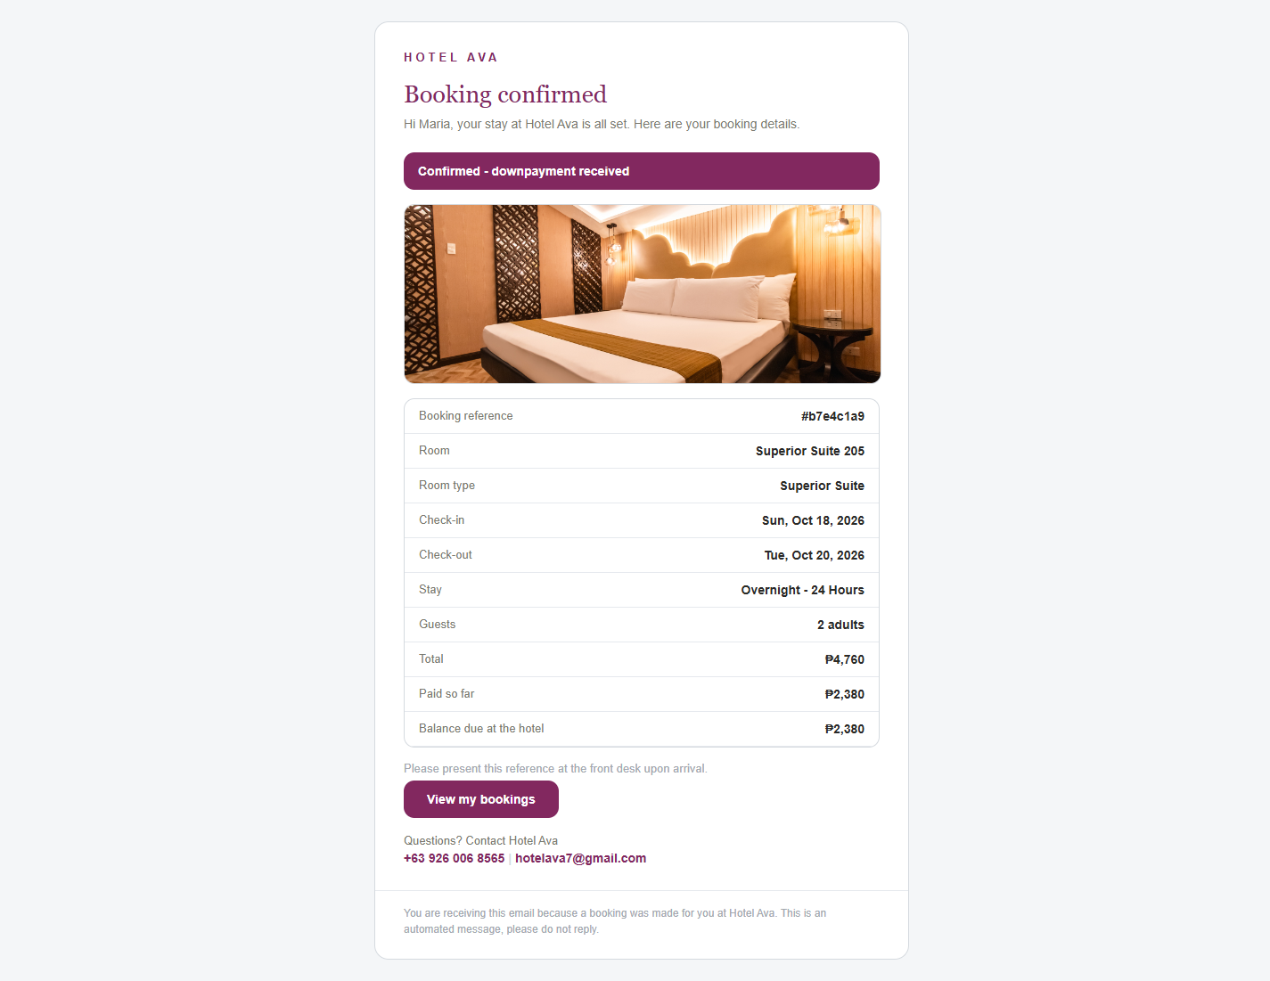
Figure 14. Booking confirmation email — the real Hotel Ava email sent after payment

4.11 My Bookings
This page lists all of your reservations with their status — Pending, Confirmed, In-house, Completed, Cancelled, or Refunded — along with the details and booking reference of each one. If you have no bookings yet, an empty state saying "No bookings yet" appears with a Browse Rooms button. You can also open the review form for a stay from here once it is finished.
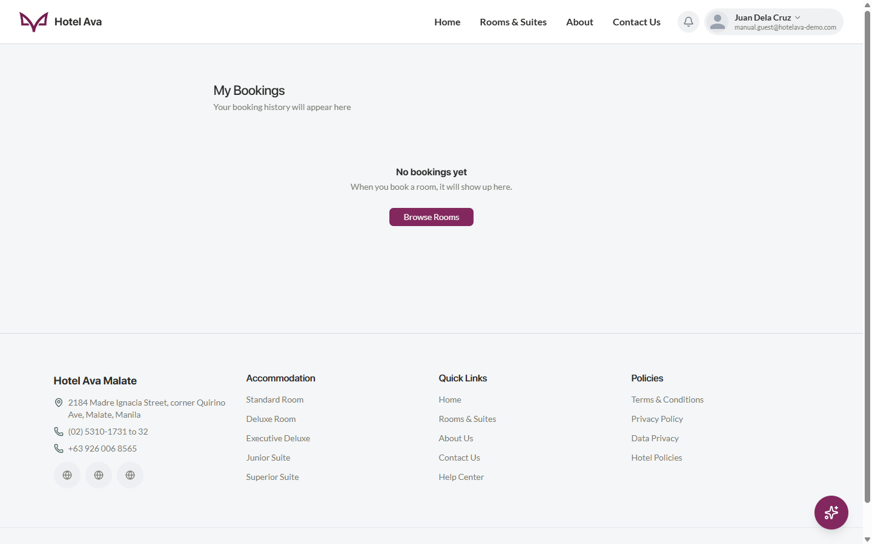
Figure 15. My Bookings — list of reservations (empty state when there are no bookings yet)
Steps:
1. Open the account menu in the header → My Bookings
2. Use the status tabs / filters to narrow down to the booking you need
3. Click a booking to see its details, reference, and status
4. After a stay is finished, you can leave a review from this page

4.12 My Reviews
My Reviews shows the reviews you have written — including the star rating and comment you gave for each room. If you have not written any yet, an empty state reminds you that reviews can be left from My Bookings after a stay. Your reviews help other guests choose a room, and admins can see them under "Ratings by room".
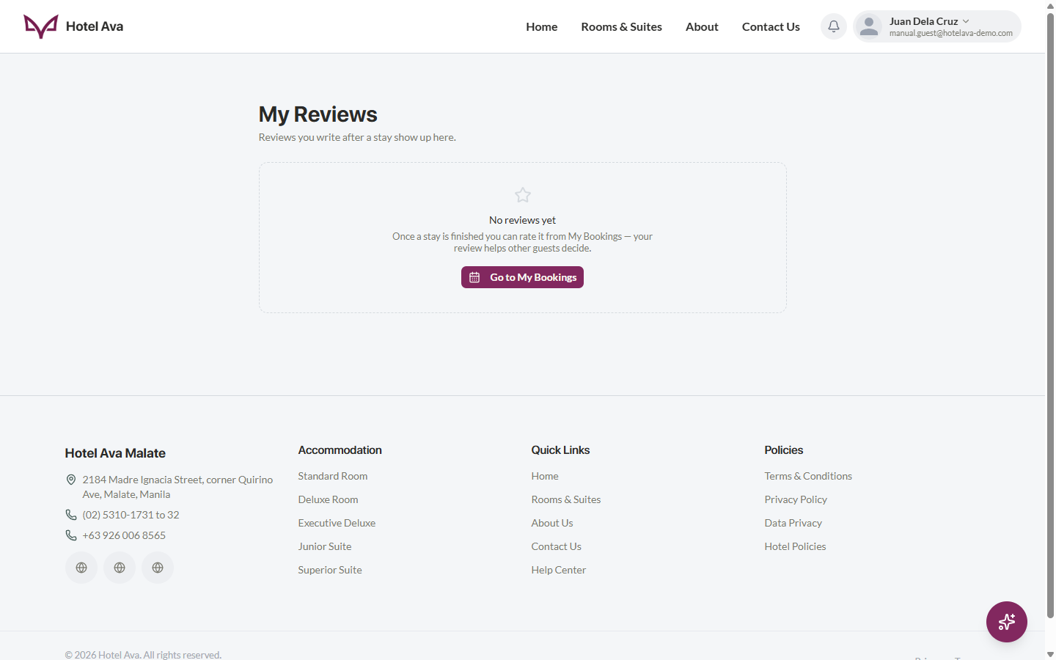
Figure 16. My Reviews — the reviews you have written
Steps:
1. Open the account menu → My Reviews
2. If you have a finished booking, click Rate / Leave a review
3. Give the room 1–5 stars and write your comment
4. Submit — it appears immediately in My Reviews and in the room's public ratings

4.13 Profile
The Profile page shows your Personal Information. Click Edit to switch to edit mode, where you can change your name (Save / Cancel appear at the top right; the name can be changed once every 30 days for security). Your email address cannot be changed — it is locked for the integrity of bookings and account security.
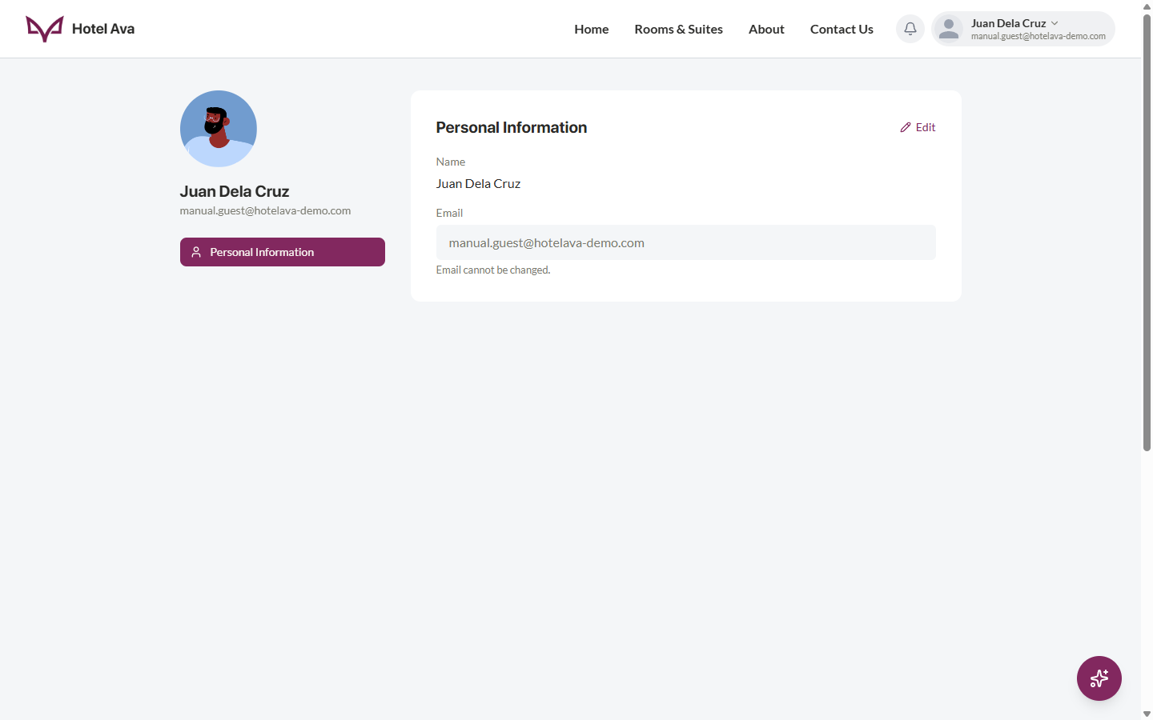
Figure 17. Profile page — personal information
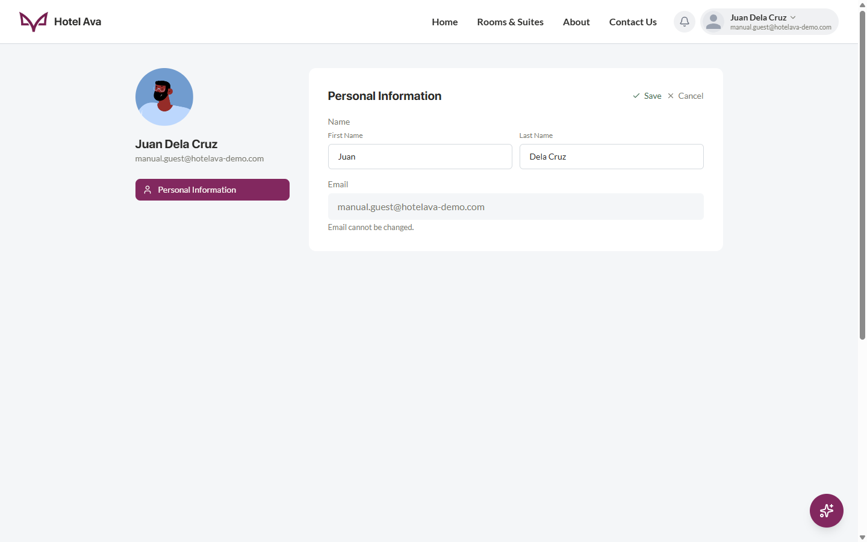
Figure 18. Profile edit mode — change your name (email stays locked)
Steps:
1. Open the account menu → Profile
2. Click Edit (top right of the Personal Information card)
3. Change your First Name / Last Name, then click Save — or Cancel to discard
4. Review your email address (cannot be changed — all bookings and security codes are tied to it)

4.14 Changing Your Avatar
Your profile picture can be changed while in edit mode on the Profile page. Click your avatar to open the Profile Picture menu with three options: Choose Avatar (pick a preset illustrated avatar), Upload Photo (use your own image), and Remove Photo (go back to the automatically generated avatar). New accounts get a generated avatar based on their name/email.
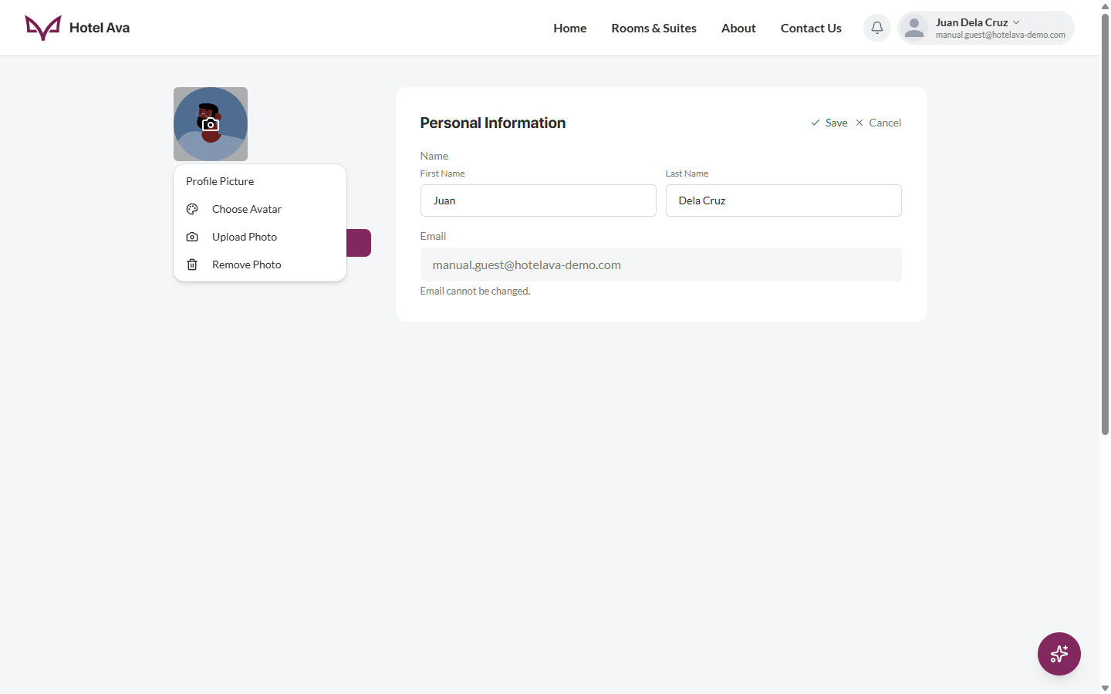
Figure 19. Profile Picture menu — Choose Avatar, Upload Photo, and Remove Photo
Steps:
1. Go to Profile and click Edit
2. Click your avatar — the Profile Picture menu opens
3. Pick Choose Avatar for a preset, Upload Photo for your own picture, or Remove Photo to reset
4. Finish with Save to apply your changes

4.15 Account Menu
Clicking your name/avatar in the header opens the account menu — your shortcut to everything personal: Profile, My Bookings, My Reviews, Settings, Help Center, and Sign Out. (Admins also see the Admin link here.)
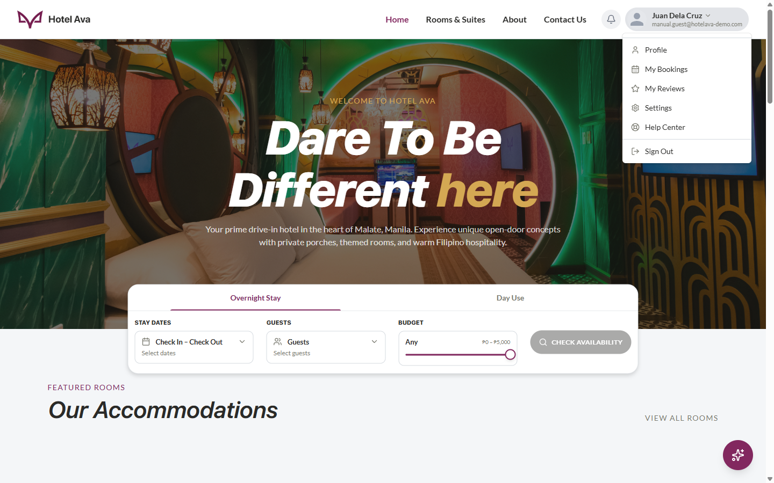
Figure 20. Account menu in the header — quick links to your pages

4.16 Settings
Settings has four tabs: Appearance, Login & security, Devices, and Quick Sign-In.
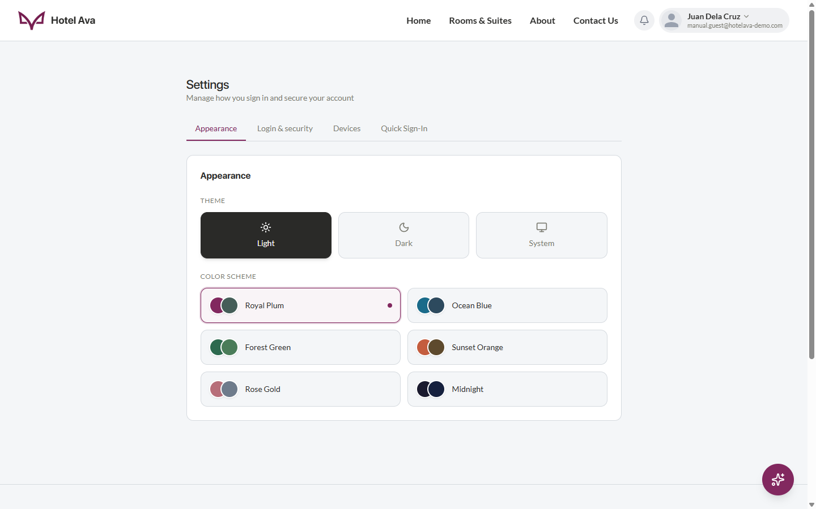
Figure 21. Settings › Appearance — theme modes and color schemes
Appearance — choose Light, Dark, or System theme and one of six color schemes: Royal Plum (default), Ocean Blue, Forest Green, Sunset Orange, Rose Gold, and Midnight. Changes apply immediately and are remembered for your account.
Login & security — two cards: Connected accounts (your Email is marked "Connected"; click Connect Google to link Google sign-in) and Change Password (enter your Current Password, New Password, and Confirm New Password, then click Update Password).
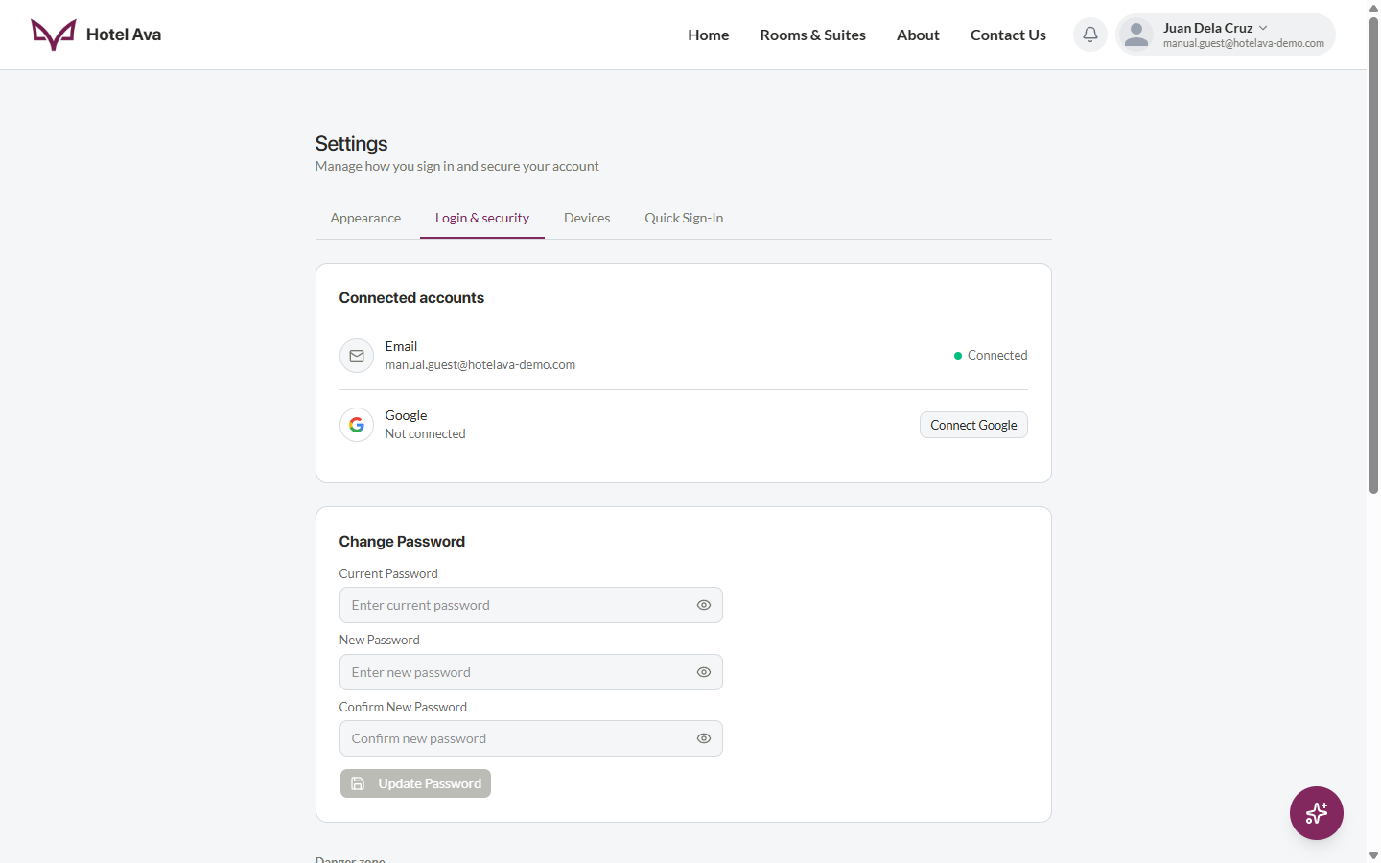
Figure 22. Settings › Login & security — connected accounts and Change Password
Danger zone / Delete account — at the bottom of Login & security. Deleting your account is permanent after a 30-day grace period, and you can cancel any time before then.
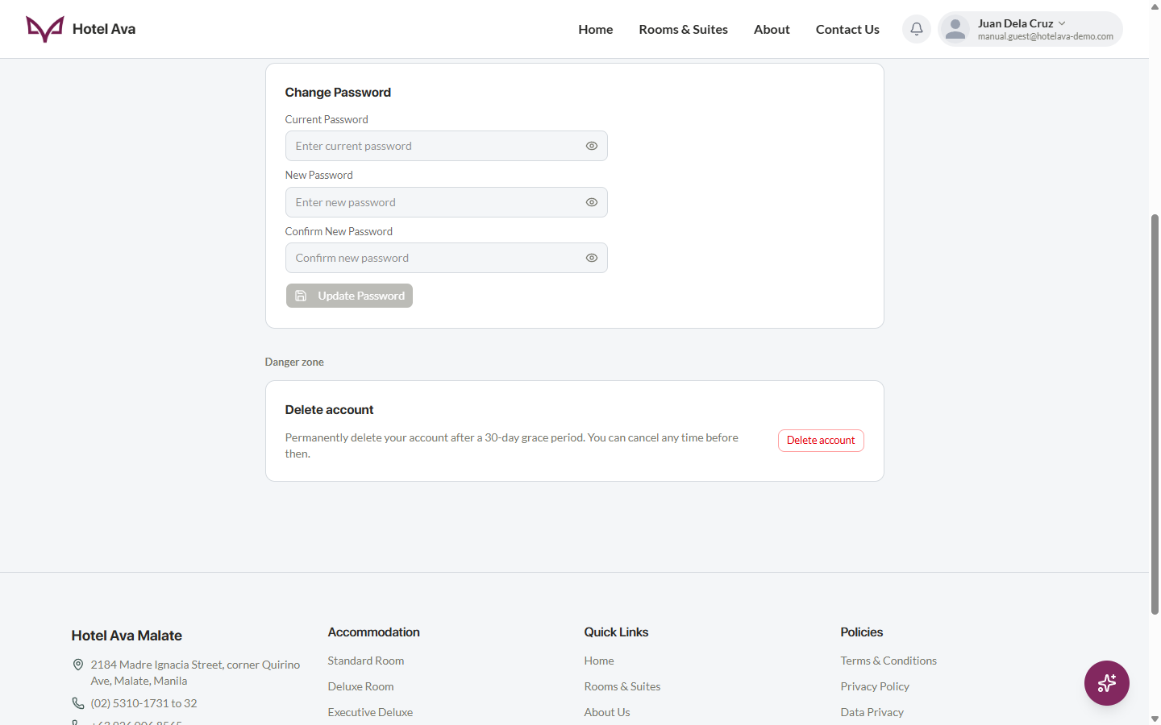
Figure 23. Danger zone — Delete account with a 30-day grace period
Devices — the Devices & activity list shows every device signed in to your account (browser and OS, last active time, and the date it was added). The current device carries a THIS DEVICE badge. Review this list regularly and sign out anything you do not recognize.
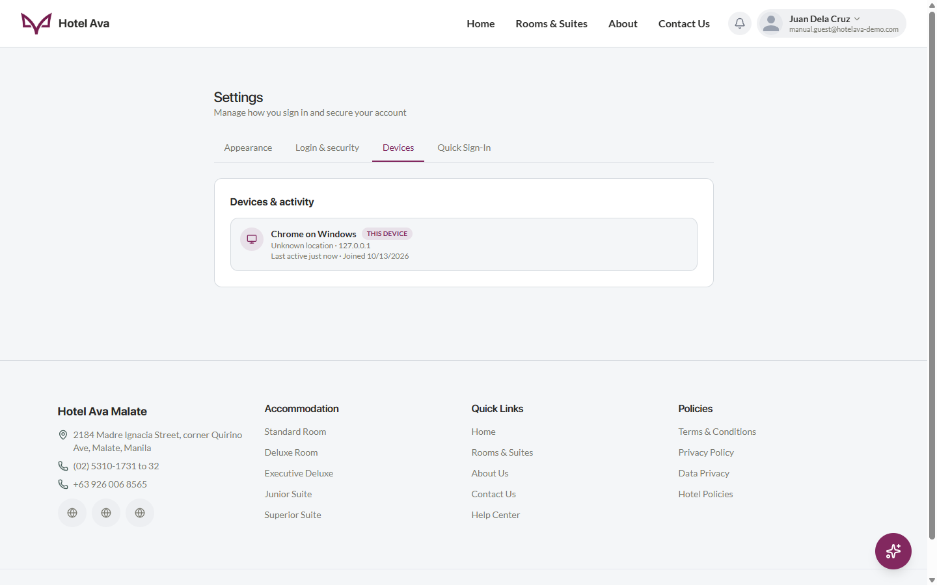
Figure 24. Settings › Devices — devices & activity
Steps (change password):
1. Open Settings › Login & security
2. Under Change Password, enter your current password, then the new password twice
3. Click Update Password — use the new password the next time you sign in
Steps (review devices):
1. Open Settings › Devices
2. Check each device's last active time and location
3. Sign out any session you do not recognize (its owner must verify again to get back in)

4.17 Ask Ava — AI Chat Assistant
The floating Ask Ava button at the bottom-right corner of every page opens the chat assistant. The panel header shows the assistant's status (Hotel Ava Assistant · Online). Ask it about bookings, payments, cancellations, check-in/out, day use, accounts, and promotions — it replies instantly. For very specific questions (for example, exact room amenities), it will point you to the front desk, and a Browse full Help Center link is always at the bottom of the panel.
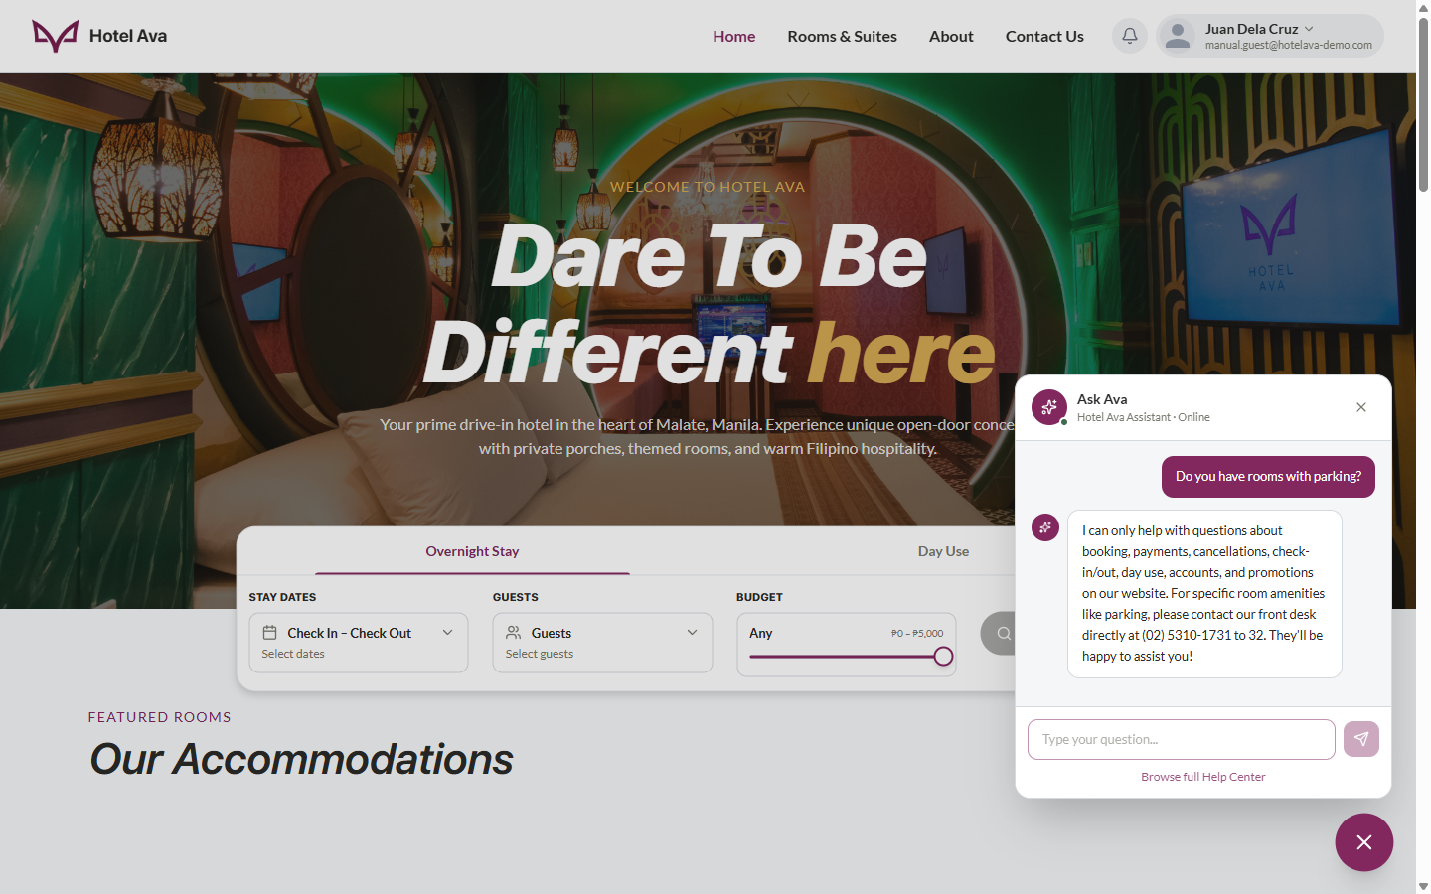
Figure 25. Ask Ava — the floating AI assistant answering a guest's question
Steps:
1. Click the Ask Ava button (bottom-right) on any page
2. Type your question and press Enter / the send button
3. Read the reply — ask follow-up questions in the same panel
4. Click Browse full Help Center for the FAQ and more help options

4.18 Help Center
The Help Center is the place for questions. It has a search bar and FAQ categories (bookings, payments, account, etc.) with ready answers, plus an AI assistant that answers follow-up questions (powered by Gemini / OpenRouter). If your question is still unanswered, the hotel's front desk contact information is also listed here.
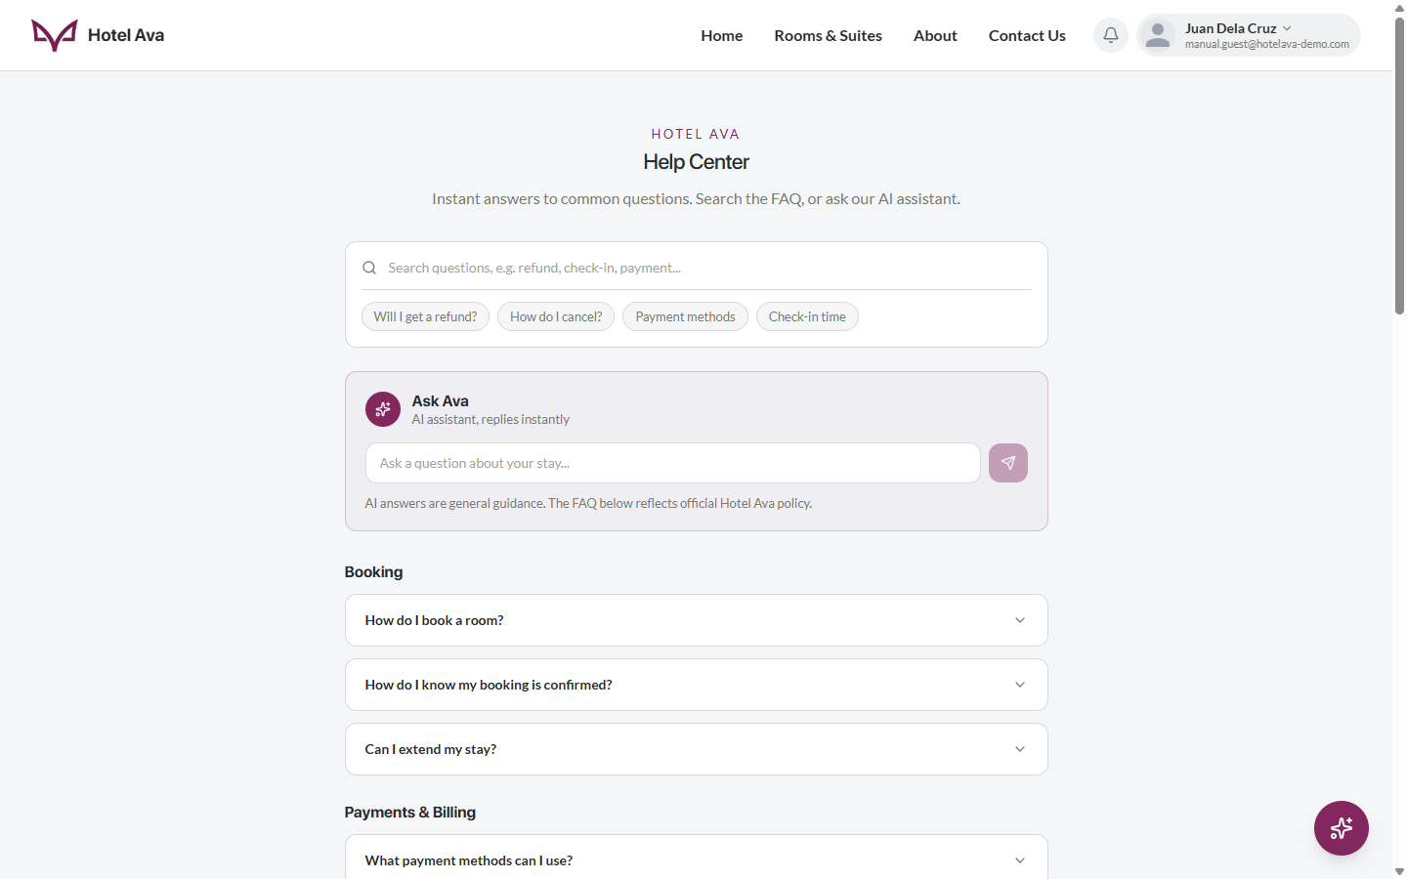
Figure 26. Help Center — FAQ and AI assistant
Steps:
1. Click the Help link in the account menu (or the Ask Ava button on any page)
2. Type your question in the search bar or pick an FAQ category
3. Use the AI assistant for more specific questions — include your booking reference if you are asking about a specific booking
4. If there is still no answer, contact the front desk using the listed contact details

5. Admin Manual

5.1 Admin Portal (Login)
The /admin portal is separate and intended for hotel staff. The left half shows the hero image and "Dare To Be Different Here at Hotel Ava"; the right half contains the login form: Email, Password, and the Sign In to Admin button. A "Back to Hotel Ava" link returns to the guest site. Note: this portal is for admin accounts only — a regular guest account will be rejected ("Access denied").
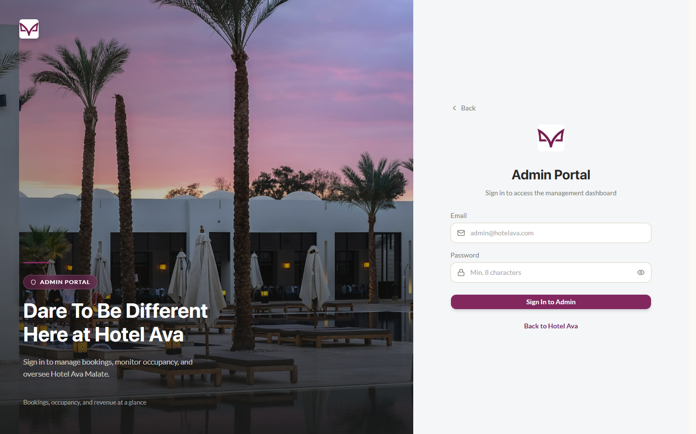
Figure 27. Admin Portal — login page for hotel staff
Steps:
1. Go to /admin in the browser (or the Admin link in the Account dropdown if you are an admin)
2. Enter the admin email and password
3. Click Sign In to Admin
4. You are taken to the Admin Dashboard, where all sections in the sidebar become available

5.2 Dashboard
This is the operations hub. The sidebar is on the left (Dashboard, Bookings, Rooms, Guests, Calendar, Reviews, AI Assistant, Other, Settings, and Log Out), with the global search bar at the top. The dashboard has three main parts:
• Operations — Arrivals today (guests due to check in today, with a direct Check-in button and a Late badge when applicable), Downpayment (total outstanding balance), and In-house (currently checked in).
• Needs attention — items that require action, such as Refunds to process (with booking count and amount).
• Performance — Monthly revenue (paid bookings by stay date, with a comparison to the same days last month), Occupancy rate, and the AI Insights card, which suggests discount ideas with a direct link to the AI Assistant.
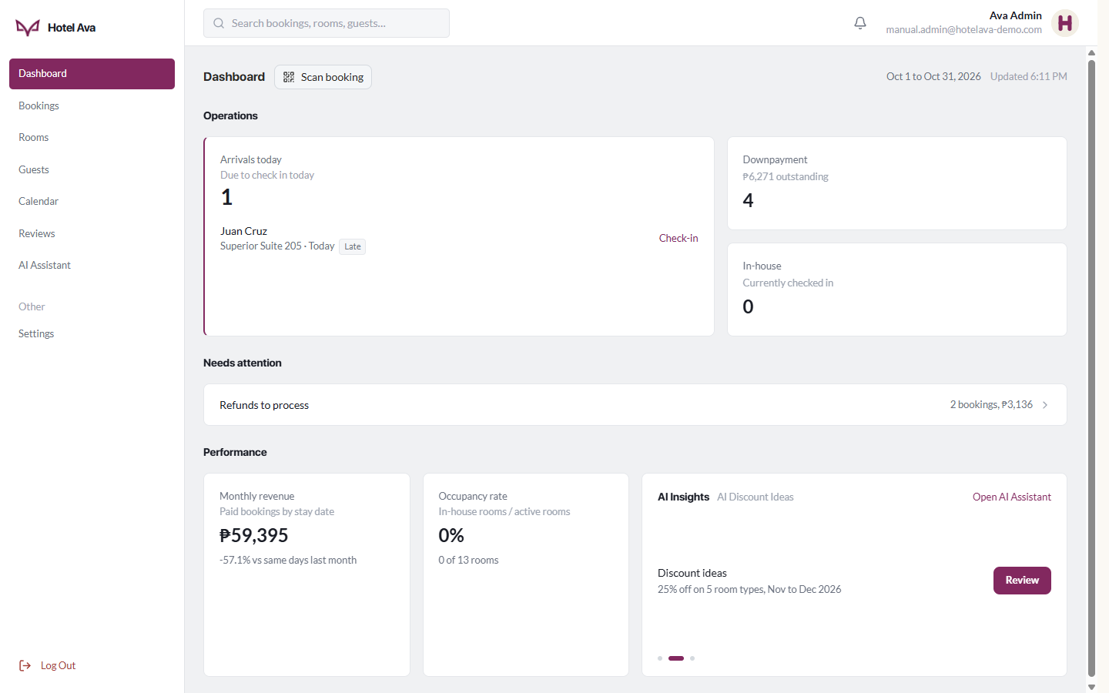
Figure 28. Admin Dashboard — Operations, Needs Attention, and Performance
Notifications — the bell icon at the top right opens the notifications dropdown with the latest alerts and a View all notifications link.
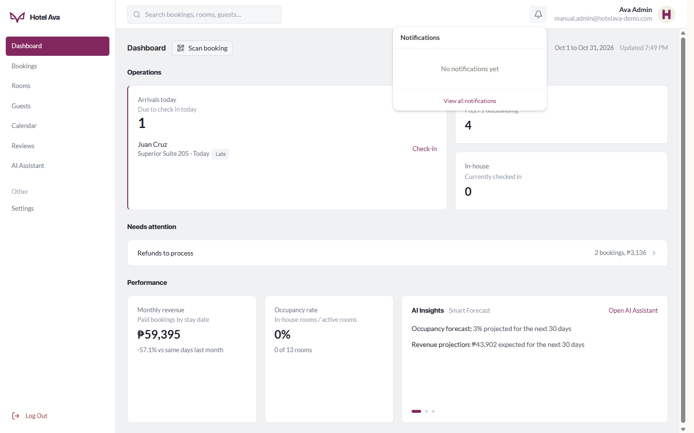
Figure 29. Notifications — bell dropdown with recent alerts
Scan booking — the button next to the Dashboard title opens the Verify guest QR code dialog. You can point the camera at the guest's QR code, upload a QR image, or paste the QR link / booking code (e.g., #6D8ED17E) and click Verify — handy at the front desk for arriving guests.
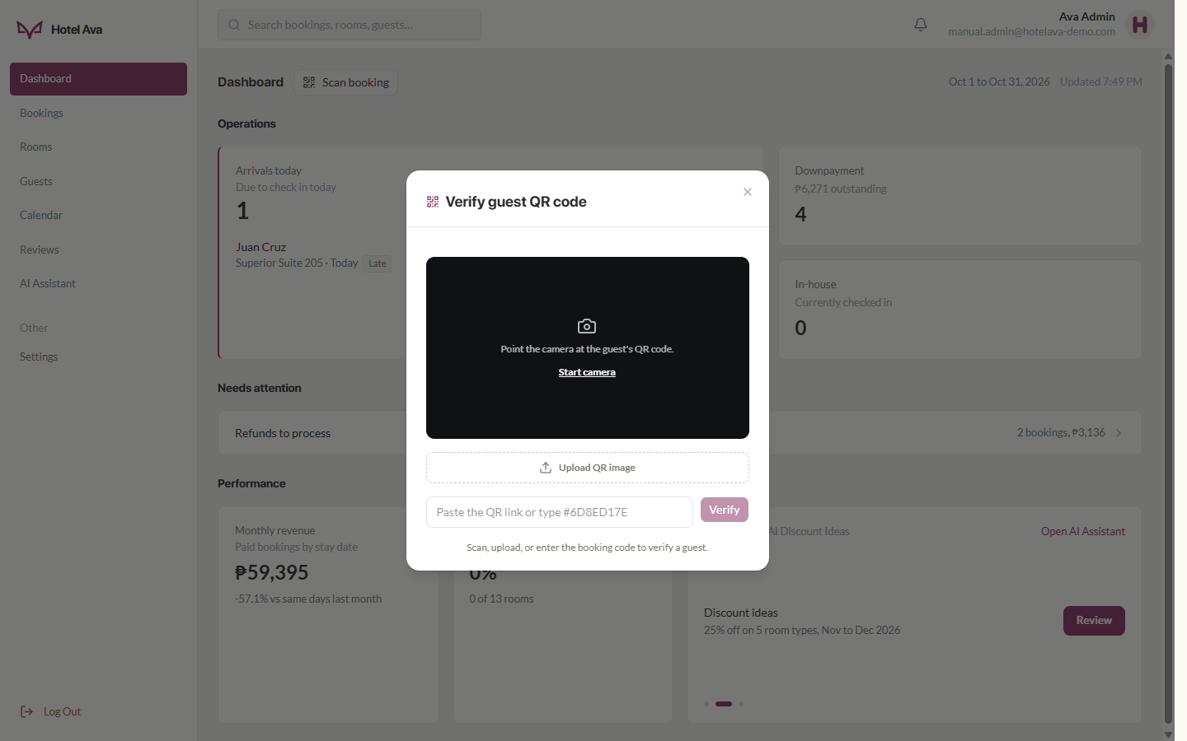
Figure 30. Verify guest QR code — camera, upload, or code entry
Steps:
1. Use the sidebar to move between sections
2. In Arrivals today, click the Check-in button to process a guest's arrival
3. Click the notification bell to see new alerts
4. Click Scan booking and verify a guest's QR code when they arrive
5. In the AI Insights card, click Review to see the suggested discounts

5.3 Bookings
This is where all bookings are managed. At the top are the status tabs with counts: All, Pending, Confirmed, In-house, Completed, Checked Out, Cancelled, Refunds, and Refunded. There is a search (name, email, booking ID, room), a room filter, and sort options. Each row shows the Guest, Stay Date, Room, Type, Amount (with a "50 paid" marker when partially paid), and Status. The Verify QR button is at the top right.
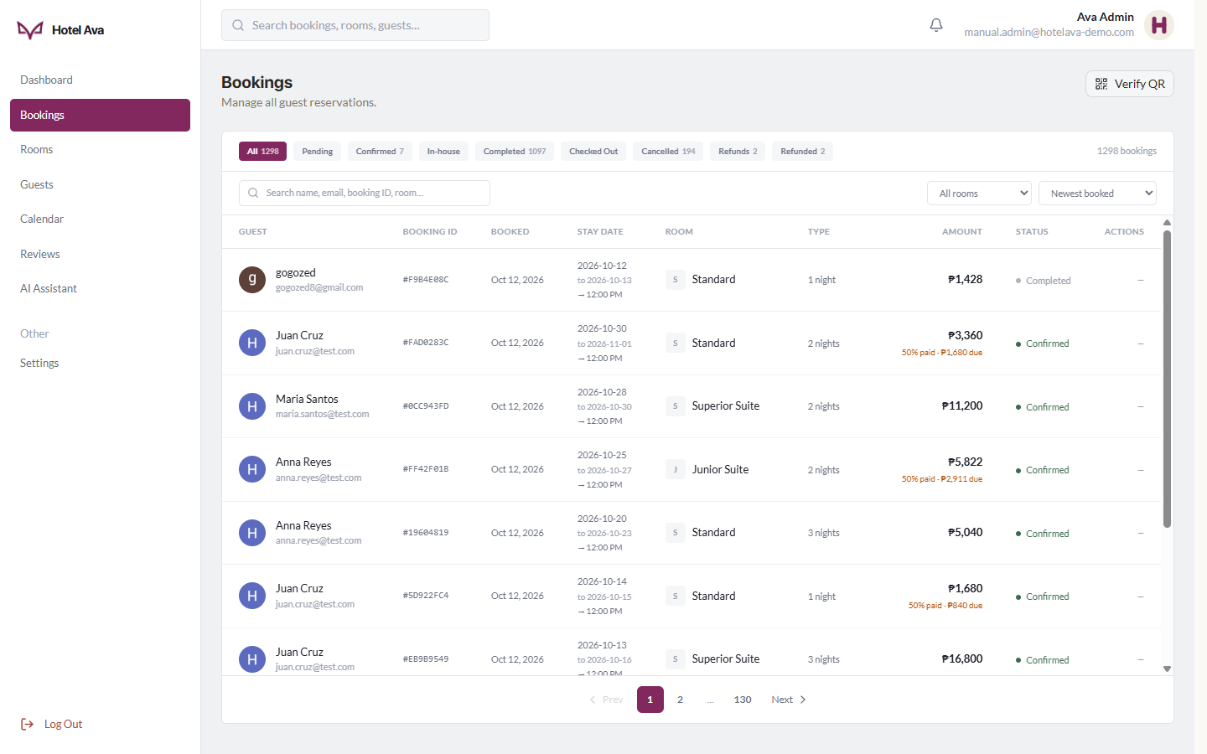
Figure 31. Admin Bookings — list, status tabs, and actions
Clicking a booking opens the Booking Details dialog: the room's photo and name, Booking ID, Booked On date, Stay dates, Room, Guests, Length, Arrival and Checkout times, and the Payment card (Method such as GCash, Amount, and Status) with a View Receipt button.
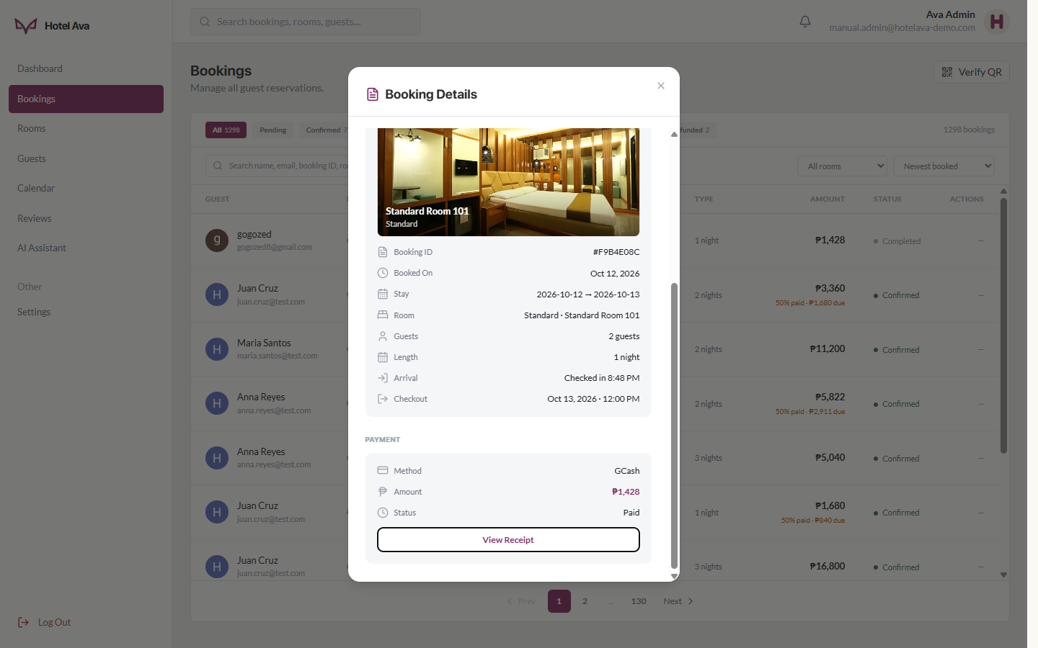
Figure 32. Booking Details — room, stay, and payment information
Steps:
1. Pick a status tab (e.g., Pending) to show only those bookings
2. Use the search to find a booking by name, email, or booking ID
3. Click a booking to open its Booking Details and process actions (e.g., review a refund, view the receipt)
4. Use Verify QR when a guest presents their booking QR code at the front desk

5.4 Rooms
The hotel's room inventory — rooms, prices, capacity, and status. Tabs are available for All, Available, Occupied, and Maintenance, along with search, a type filter, and sort. Each row shows the photo, Room ID, name, type badge, price, capacity (adults, children, pet friendly), status, number of bookings, revenue, and actions (edit / delete). The + Add Room button at the top adds a new room.
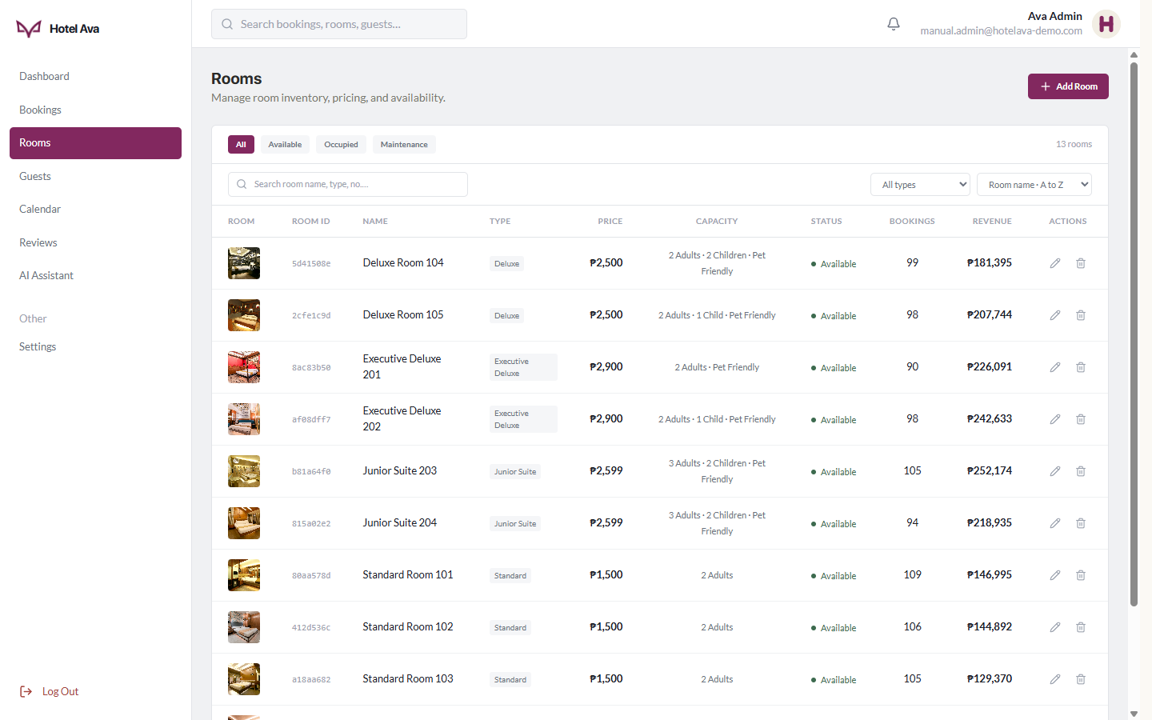
Figure 33. Admin Rooms — inventory, pricing, and revenue per room
The Add New Room dialog collects everything a room needs: Room Details (Room Name, Type, Price per night, optional Day Use Pricing for 3h / 6h / 8h / 12h — leave blank to auto-price from the nightly rate, Max Adults / Children / Pets where 0 means not allowed, auto-computed Total Capacity, Status, and the About description) and Room Images (up to 5). The same dialog is used when editing via the pencil icon.
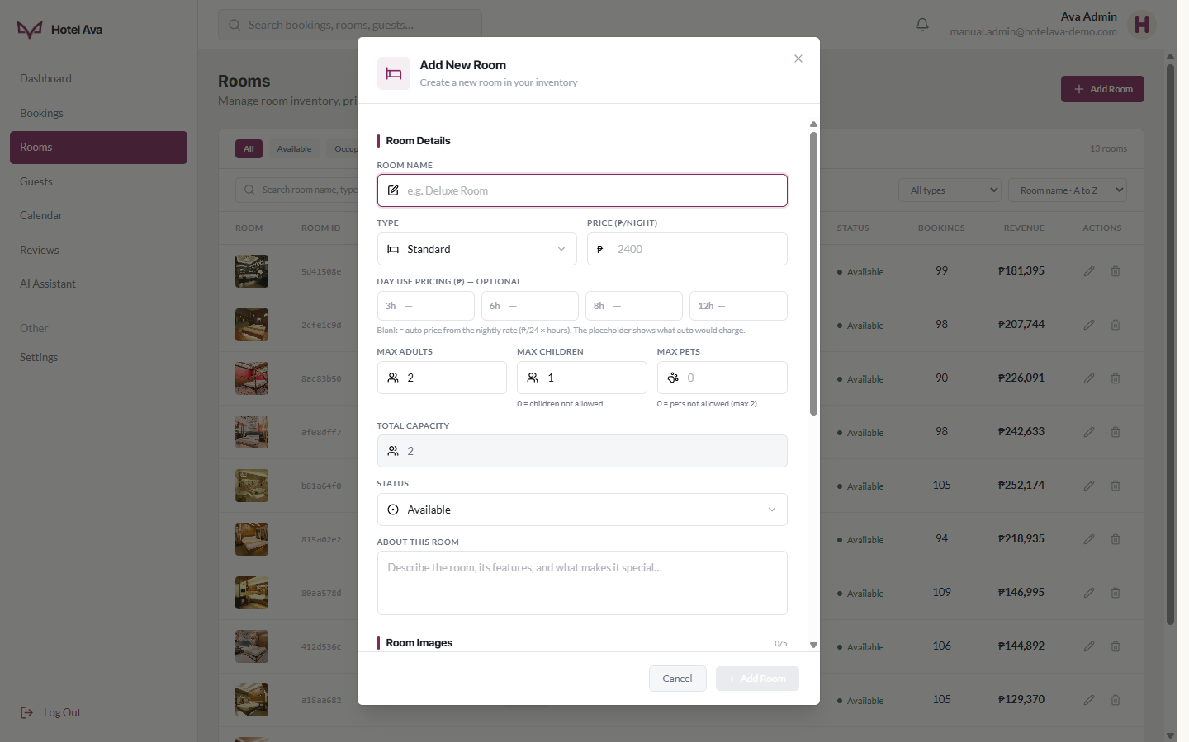
Figure 34. Add New Room — room details, day-use pricing, and images
Steps:
1. Click + Add Room to add a new room (name, type, price, capacity, images)
2. Use the pencil (edit) icon in a row to change a room's price or details
3. Use the trash (delete) icon to remove a room (be careful — a confirmation will appear)
4. Filter by status to see which rooms are Available or Occupied

5.5 Guests
A list of guest profiles and stay history. Each row shows the avatar and name, email, number of bookings, total spent, and last stay. Search and sort options (e.g., Top spenders) make it easy to find your most valuable guests.
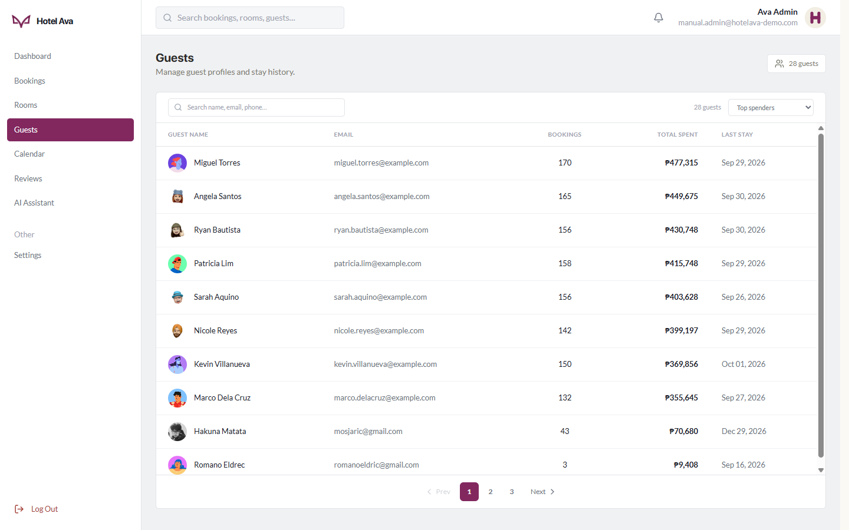
Figure 35. Admin Guests — profiles and stay history
Steps:
1. Use the search to find a guest by name or email
2. Pick a sort order (e.g., Top spenders) as needed
3. Click a guest to see their booking and stay history

5.6 Calendar
A monthly calendar view of all bookings — you can see who is booked on each day at a glance. Entries are color-coded by room type according to the legend at the bottom (Standard Room, Deluxe, Executive Deluxe, Junior Suite, Suite, Superior Suite). Use the arrows to move between months; the current day is highlighted.
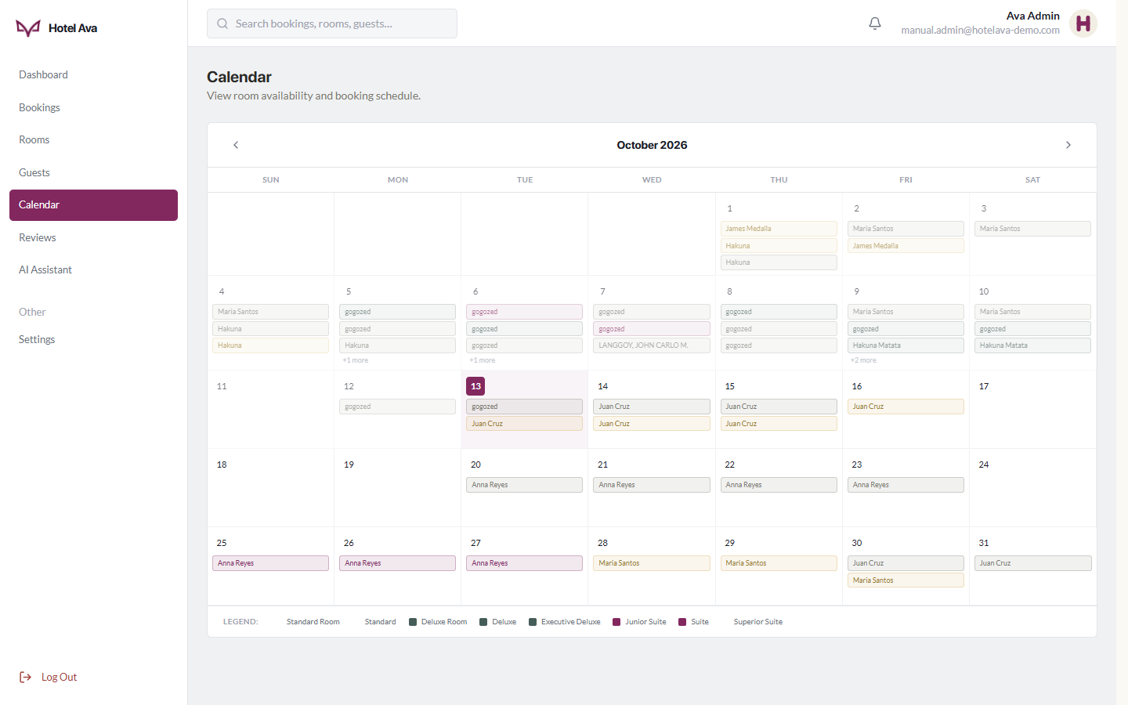
Figure 36. Admin Calendar — daily booking calendar
Steps:
1. Use the < and > arrows at the top to change months
2. Read the color-coded entries to see occupancy per day
3. Click a day or booking to see its details

5.7 Reviews
Guest sentiment and ratings. Three summary cards sit at the top: Overall Rating (e.g., 4.1 out of 5), Total Reviews (e.g., 669), and Rooms With Reviews (13/13 — every room has reviews). Two tabs are available: Ratings by room (average rating and review count per room) and All reviews (each individual review).
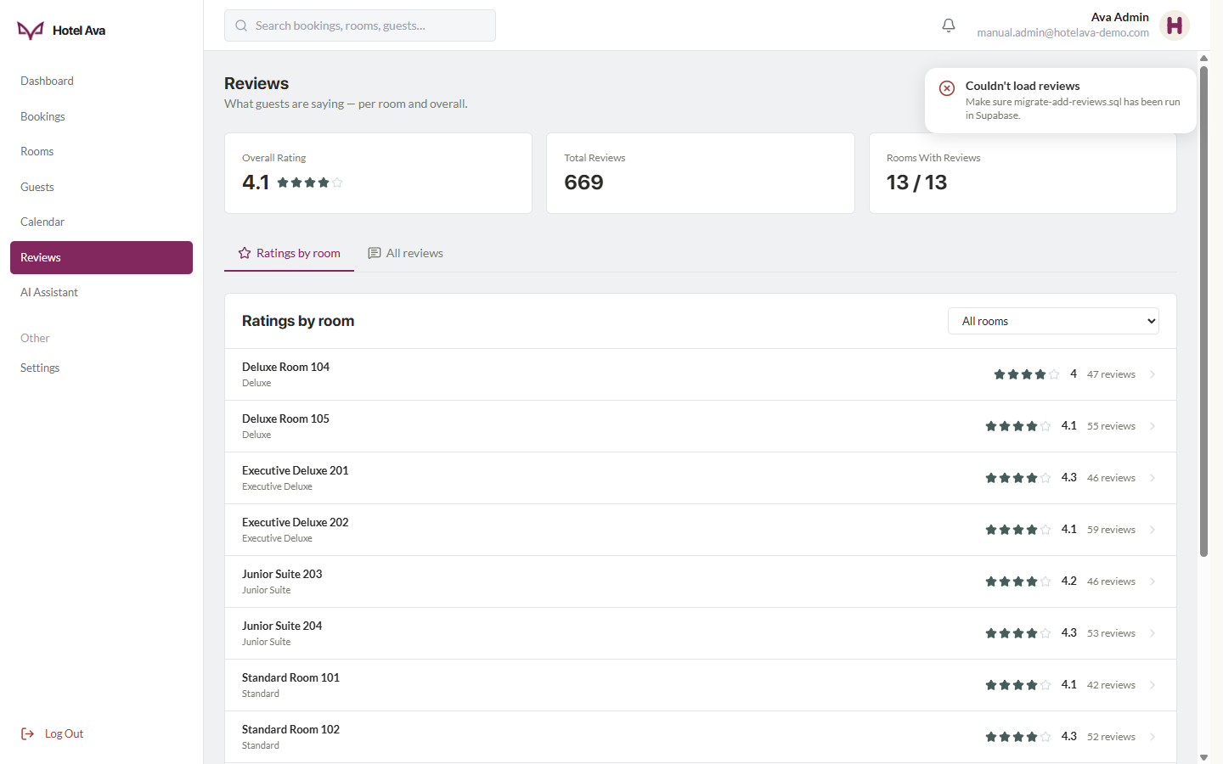
Figure 37. Admin Reviews — overall rating and ratings by room
Steps:
1. Check the Overall Rating cards for a quick summary
2. In Ratings by room, click a room to see its reviews
3. Use the All reviews tab to read every guest comment

5.8 AI Assistant
The hotel's AI analytics hub. It has three tabs: Smart Forecast, Discounts, and Hotel Stats. In Smart Forecast, the AI-Powered Insights strip shows three cards — "How full we'll be" (occupancy projection for the next 30 days, with a trend label such as TRENDING DOWN), Expected earnings (revenue for the next 30 days, with a percentage change), and Discount ideas (number of active proposals). Below are two charts: Demand Forecast (actual vs. predicted occupancy with seasonality) and Revenue Forecast (actual vs. predicted monthly revenue), both with a "Today" marker.
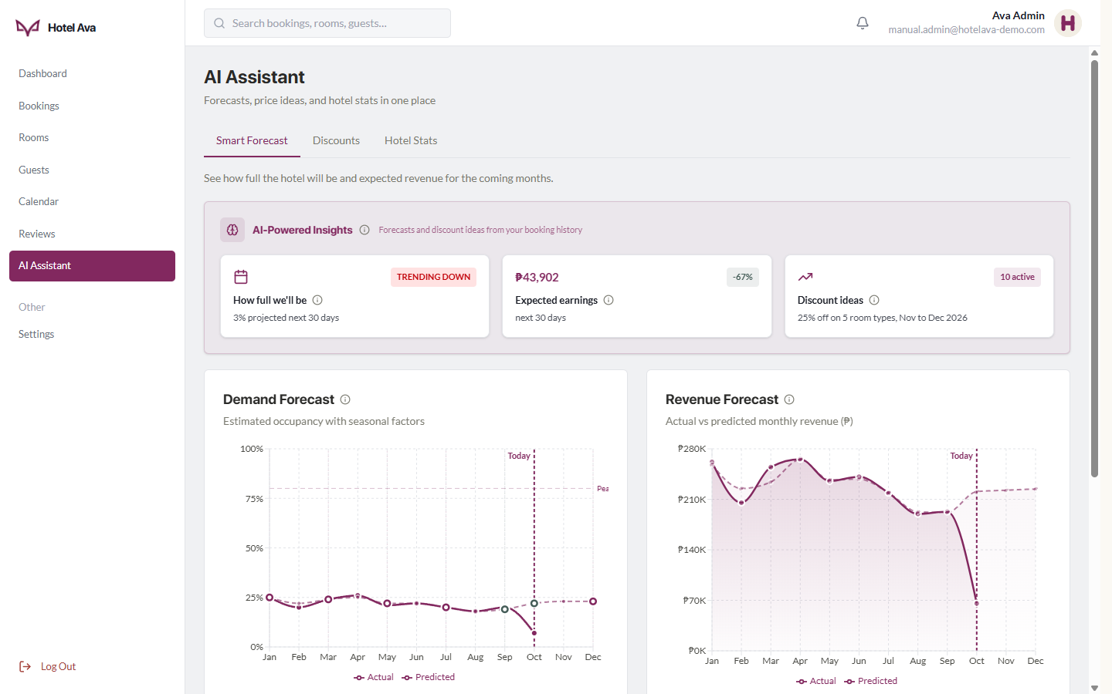
Figure 38. Admin AI Assistant — Smart Forecast, charts, and discount ideas
The Discounts tab has two sub-tabs: Room Demand and Holiday Discounts. When the AI detects weak bookings, a banner such as "5 room types need a boost" appears. Each room-type card shows the number of rooms, upcoming bookings, projected occupancy for the next 30 days, a Critical label with nights booked, the 90-day average occupancy, and the current rate — plus a suggested discount (e.g., 15% off with the old and new price) and an Apply Discount button.
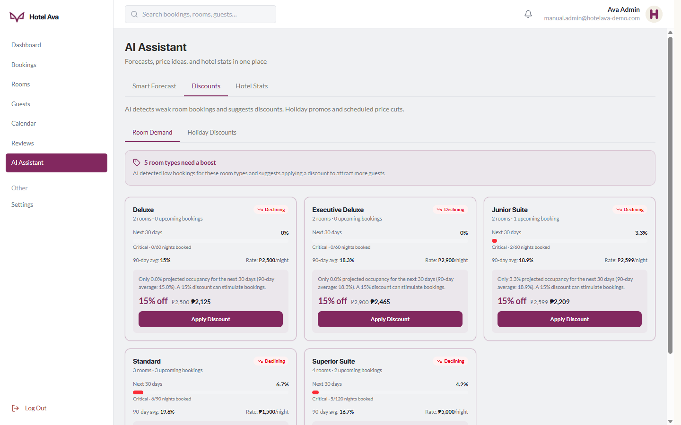
Figure 39. AI Discounts — room demand and suggested price cuts
The Hotel Stats tab summarizes performance: the Seasonal Trend chart (monthly booking volume and revenue, with peak season vs. off-peak), Room Performance (revenue by room type for the current month, with occupancy, nightly average, and total), and summary cards: Total Bookings, Best Room, Total Revenue, and Peak Months.
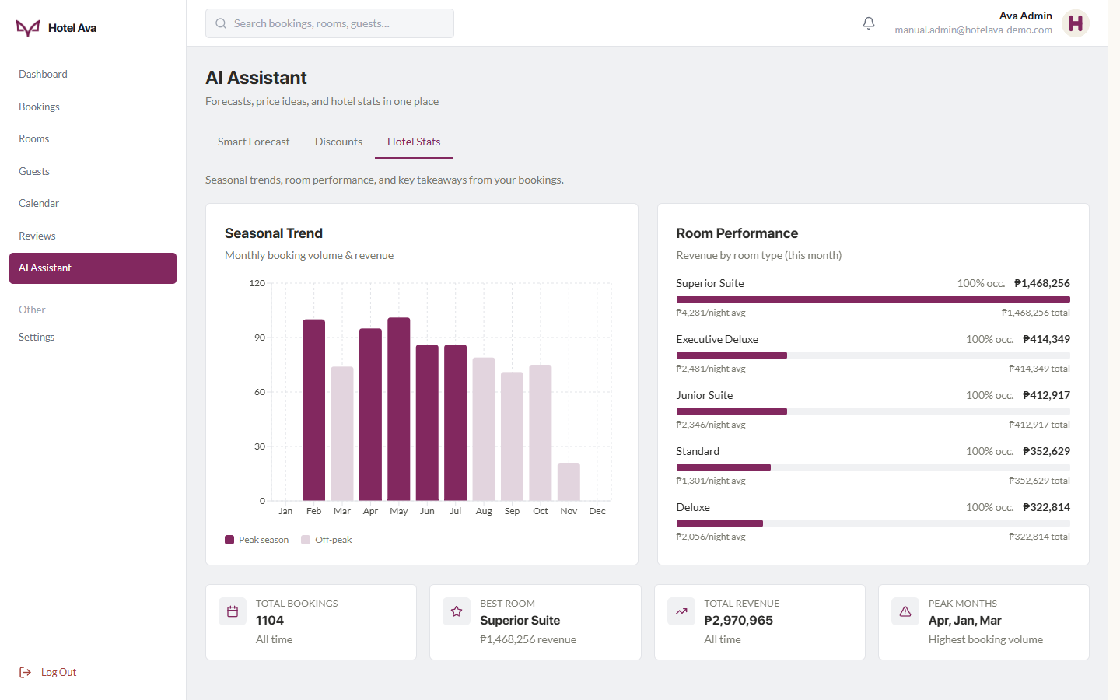
Figure 40. AI Hotel Stats — seasonal trends and room performance
Steps:
1. The Smart Forecast tab opens by default — read the insight cards at the top
2. Scroll down for the Demand Forecast and Revenue Forecast charts (solid = actual, dashed = predicted)
3. Open the Discounts tab to review AI-generated discount ideas and click Apply Discount on the ones you want
4. Open the Hotel Stats tab for seasonal trends and per-room-type performance

5.9 Admin Settings
The admin account's profile and security. It shows the avatar and name (e.g., "Ava Admin") with the subtitle "Hotel Ava Administrator" and an Edit button, plus the Profile and Security tabs. Personal Information includes the email address, phone, Role (Administrator badge), Joined date, and Location.
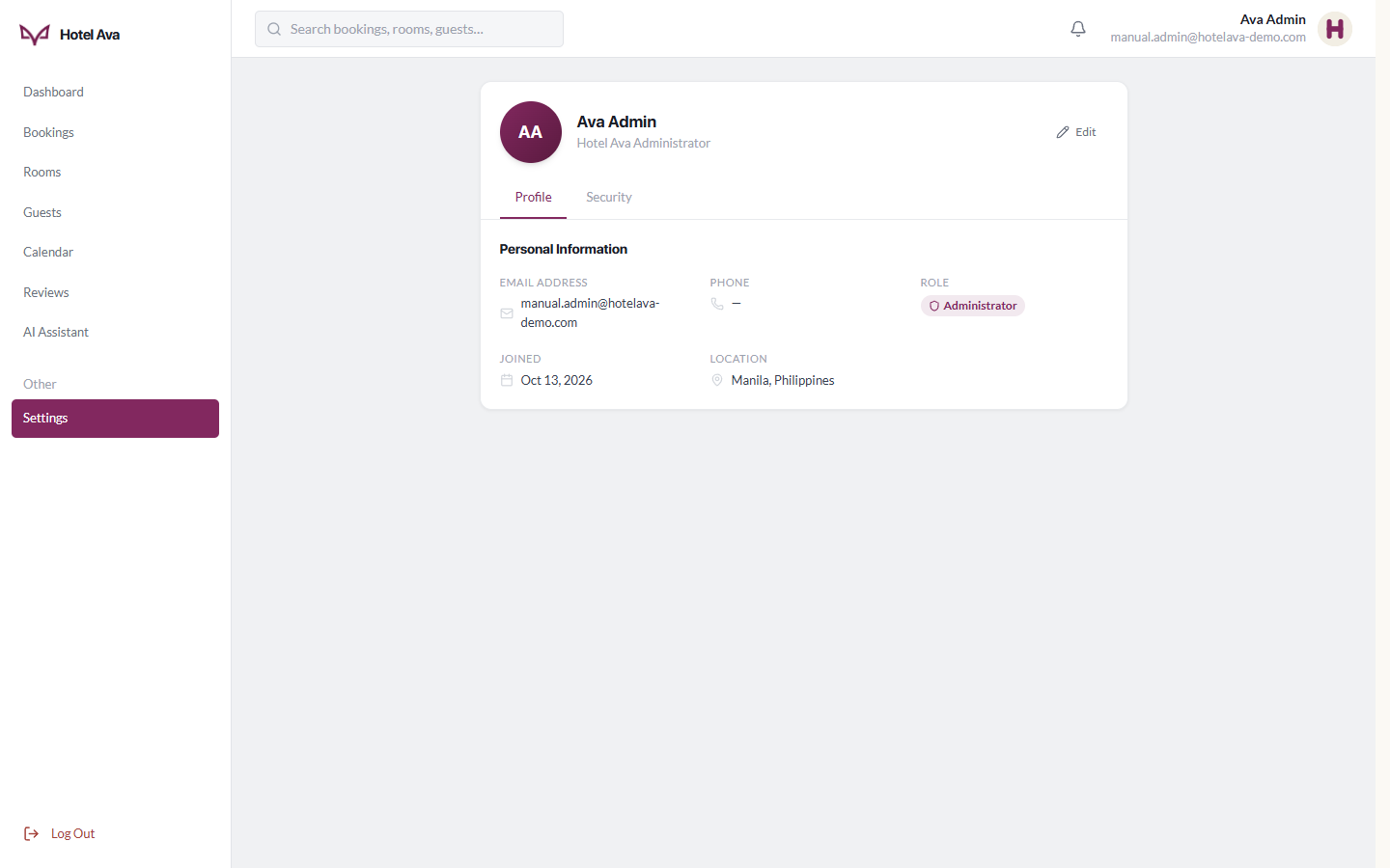
Figure 41. Admin Settings — admin account profile and security
Steps:
1. Click Edit to change the admin's name or phone number
2. Use the Security tab for password and security settings
3. To sign out, click Log Out at the bottom of the sidebar

6. FAQ / Troubleshooting
• "Access denied. This portal is for admins only." — a guest account was used in the Admin Portal (/admin). That portal is for admin accounts only; go back to the normal Sign In page if you are a guest.
• What is the "Verify it's you" code? — a one-time code (OTP) sent to your email when signing in from a new device (see 4.7). Once verified, that device is remembered.
• How do I sign in on another device without a password? — use Quick Sign-In: open the QR/code screen on the new device's login page, then approve it from Settings › Quick Sign-In of your signed-in device (see 4.8).
• How do I change my password? — Settings › Login & security › Change Password: enter the current and new password, then Update Password (see 4.16).
• I forgot my password — use "Forgot password?" on the Sign In page; the system will email you a reset link (see 4.9).
• How do I change my avatar / profile picture? — Profile › Edit › click your avatar, then Choose Avatar, Upload Photo, or Remove Photo (see 4.14).
• Can I change my email? — no; the email on your Profile is locked for security and booking integrity.
• How do I see the devices signed in to my account? — Settings › Devices (see 4.16). Sign out anything you do not recognize.
• How do I delete my account? — Settings › Login & security › Danger zone › Delete account. It is permanent after a 30-day grace period, which you can cancel any time.
• Why is my booking not showing in My Bookings? — the payment may not have completed. Check your confirmation email, or try again from Room Details.
• The payment failed — the Payment Failed page will appear and you can try again. For the demo, make sure you are using PayMongo's test card.
• What is "AI Boost" in the price? — a discount given by the AI based on demand forecasting; it appears in the Price breakdown on the Room Details and Booking pages.
• What is Ask Ava? — the floating AI chat assistant on every page (see 4.17). For room-specific questions it will direct you to the front desk.
• I am not receiving any email (verification, OTP, or booking confirmation) — check your Spam/Junk folder and make sure the email address is correct.

7. Demo Accounts
The accounts below were used to produce this manual and can be used to demonstrate the system:
Account | Email | Password | Role
Demo Guest | manual.guest@hotelava-demo.com | HotelAvaManual2026 | Guest
Demo Admin | manual.admin@hotelava-demo.com | HotelAvaManual2026 | Admin

Note: These accounts were created exclusively for demonstrating this manual. Replace or remove them before final submission, and never expose the passwords in a production deployment.
This manual was produced from the actively running system (October 2026) — all images are real screenshots of the system using demo/seed data.

